sPOT APPLICATION TOOL FOR WAVE DRIVEN NEARSHORE HYDRODYNAMICS
Hoda El Safty and Patrick Lynett
Nearshore hydrodynamics are driven by a wide spectrum of motions/scales that vary on the order of O (10) m to O (100) km. These scales have different effects on the dynamics of the nearshore areas, and capturing these effects is essential in accurately modeling the nearshore processes such as: mixing and transport of pollutants, wave steeping and/or wave damping, erosion and deposition of sediments, and infragravity wave propagation. For example, in tidal inlets, waves interact with tidal-currents and bathymetry. The presences of waves alter the kinematics and the dynamics of the tidal-currents such as increasing the bottom friction due to wave bottom boundary layer and changing the vertical profile of the horizontal velocity from the well-known log profile. The tidal-currents affect the wave kinematics and dynamics such as Doppler shift, wave refraction, and wave steeping in opposite currents, wave breaking and infragravity wave propagation. The time and length scales of the current are much larger than those of the waves, and modeling this interaction using a single numerical model is numerically expensive. One approach to overcome this issue is through using multi-scale numerical modeling by coupling two or more numerical models. In literature, spectral wave models have been widely coupled with circulation models to study wave-current interaction. These spectral models can provide accurate predictions for wave height but they don’t provide accurate information about nonlinear wave statistics, i.e. wave skewness and asymmetry, which is a key parameter in sediment transport models. On the other hand, the phase-resolving models are capable of providing this information. In the current study, the large-scale circulation model, Delft3D, is coupled with time-domain Boussinesq-type wave model. The use of time domain wave model in the numerical coupling will improve the prediction of various nearshore processes such as: wave breaking and thus infragravity wave release and propagation, combined vertical velocity structure under external forcings of tidal currents. Such an application will fulfill the community needs for a "spot application tool" where we simulate wave-driven processes in a large domain with fine-resolution.
Keywords: wave-current interaction; Tidal Inlet; Boussinesq model; Delft3D; SWAN.

INTRODUCTION
A commonly encountered situation in coastal areas is the interaction of waves, tidal-current, and bathymetry at tidal inlets. This interaction has strong effects on navigation safety, flooding, sediment transport, beach erosions, and mass exchange between the two water bodies, i.e., ocean and river. In tidal inlets, the horizontal pressure gradient balances the bottom shear stress in the momentum equation in absence of waves. When waves are present, they play an important role that can change the dynamics via wave-current interaction and wave breaking. For example, tidal-currents experience enhanced bottom roughness due to existence of the wave bottom boundary layer. This enhanced friction affects jet spreading at the river mouth and could change the jet direction. The recent field observations at the New River Inlet during tropical storm Alberto show that spatial gradients of radiation stresses increase the landward-directed flows (Wargula 2014). Also, the waves could get steeper in existence of strong opposing current. (Swan 1990) conducted an experiment of monochromatic wave interacting with turbulent tidal jet and the results show an increase in the wave height before breaking up to 250 % in the ebb current and decrease of 40 % in the wave height in the flood current. This wave steepening in turns affects the wave breaking location and thus the infragravity waves release and propagation. Moreover, this wave steeping can cause severe danger for navigation through the inlet channel. It is said that "New river inlet is considered dangerous by the local pilots, and entrance should not be attempted except under most favorable conditions. A strong ebb current from the inlet causes a break on the bar when there is a sea outside. The break is especially bad when the ebb sets against a south or southeast wind." (http://nc.usharbors.com/harbor-guide/new-river-inlet).
Consequently, there is a critical need to understand the nature of this interaction at tidal inlets in order to be able to save lives and avoid costly and devastating damages. However, studying and understanding the hydrodynamics resulted from this interaction at is still a challenge to the scientific community due to its complexity for the following reasons. First, the existences of wide spectrum of motions/scales and capturing their effects are essential in modeling the hydrodynamics. Second, the interactions between these different motions occur in a nonlinear way that prevent us from simply superposing their individual effects and/or prevent us from implementing simple models. Third, these motions vary in their length scales, on the order of O (10) m to O (100) Km, and in their time scales, on the order of seconds to days during storms. This large difference in length and time scales increases the numerical difficulty in using single numerical model to investigate both small and large scale effects and obtaining accurate results. Moreover, these motions interact in a continually dynamic way that generates small scale features that significantly affect other processes in the nearshore zone. Therefore studying river mouth dynamics and tidal inlets will increase the Navy's capability to navigate safely in such complex environments.
In literature, field and experimental studies and/or numerical models are the possible candidates to address this problem. Field experiments are the more accurate data to obtain. However, field studies of such nearshore-zone interaction is hard to measure or is hard to control, which makes it very challenging to extract the required information. The other approach is through using numerical models. These numerical models are considered to be a promising tool especially with the continually increasing technology resources.
In this study, we address the problem numerically. Usually, two or more numerical models are coupled to cover the wide spectrum of motions/scales: a circulation model and a wave model. They are coupled in a one-way coupling or in a two-ways coupling. Each model focuses on specific scales with optimized resolutions. This coupling between the various models has helped analyzing near field processes, order of meters resolutions, and far field processes, order of kilometers resolutions. This approach has attracted many researchers and it has shown notable achievements in different applications. For example, (Morelissen 2013) dynamically coupled Deflt3D-FLOWas a far field model with CORMIX model as a near field model to study dispersion and environmental impacts of outfall plumes. (Veeramony 2012) studied the inundation caused by Hurricane IKE2008 using Delft3D-Flow coupled with SWAN; they show the effects of coupling on the water levers. (Nardin 2012) studied the effect of waves on the growth development of mouth bar using Delft3D-SWAN coupled with Delft3D sediment transport module. They emphasize the effects of wave characteristics, wave height and wave period, on mouth bar formation and that waves could change the river jet direction through increasing the bottom shear stresses at the river mouth that affect the jet spreading as well. (Chen 2012) have studied the interaction between tidal flow and waves at "new rivet inlet" using open source NearCom-TVD model. NearCom-TVD model is a coupled quasi-three dimensional circulation model, SHORECIRC with spectral wave model SWAN. (Condon 2012) coupled Delft3d-Flow with SWAN to develop storm surge inundation prediction tool. They modeled the storm surge produced from Hurricane IKE occurred in September 2008 along the Gulf Mexico coast. (Elias2012) used field data measured at the Mouth of Columbia River to calibrate the coupling of Delft3d-Flow with SWAN and then they used it to study the energetic tidal inlet while including the effect of tidal currents, river discharge, and wave-driven currents.
Majority of the previously mentioned wave models used in the numerical coupling are spectral-type wave models. They solve energy balance equation for energy density spectrum using source terms for wind input, nonlinear wave-wave interaction, energy dissipation due to whitecapping, and energy dissipation due to bottom stresses. Although these models could take less computing time compared to phase-resolving time-domain wave models and could give accurate predictions for wave height, they don’t provide accurate information about higher order nonlinear wave statistics quantities and fluid kinematics at breaking zone which are key parameters in studying nearshore processes. To enhance our understanding and analysis of the wave-current interaction at tidal inlets, a large-scale circulation model is coupled with time-domain phase-resolving wave model in this study. A set of depth-integrated Boussinesq equations are derived with background current forcings included. The numerical model is validated through comparison with available experimental data sets such as: monochromatic wave interacting with orthogonal current and irregular waves interacting with opposing current, not presented in this paper. Afterwards, the numerical coupling between Delft3D model and Boussinesq wave model is applied to the field site, New River Inlet located in North Carolina. A one way coupling between the two models is outlined as follow: First, Delft3D-FLOW model run for the large domain to simulate the tidal-current without including the waves. Second, the current information is extracted for the required area of interest and passed to the wave model. Finally, the Boussinesq wave model is run with the background current forcing for the required area of interest at the desired time. Consequently, the same simulation using Delft3D-FLOW model coupled with Delft3D-SWAN model is carried out and the results are compared with the results of the coupled Delft-Boussinesq for the same simulation.
This coupling will enhance our understanding of the complex dynamics that exits in coastal areas like tidal inlets where interactions between waves, tidal-current, and bathymetry. The use of time-domain model clarifies wave role in generating vortices around the entrance of inlets. Such an application will fulfill the community needs for a "spot application tool" where we simulate wave-driven processes in a large domain with fine-resolution.

DELFT3D AND SWAN MODEL SETTINGS

The numerical model, Delft3D, is a comprehensive modelling package that is developed by Delft Hydraulics, (www.wldelft.nl). The model consists of various modules that make it capable of simulating different nearshore processes. In this study, the open-source of Delft3D is installed and is compiled using Visual Studio 2008 and Intel FORTRAN complier. The Graphical User Interface (GUI) is used for preparing the required input files and creating the plots of the results. The wave module in Delft3D is the spectral wave model SWAN. The model SWAN is third generation wave model that computes the spectral evolution of waves including: wind forcing, nonlinear wave-wave interaction, energy dissipation due to whitecapping, and energy dissipation due to bottom stresses. SWAN solves the action balance equation to estimate the evolution of wave action density. The coupling of Delft3d-Flow module with Delft3d-Wave module could be done in a one-way coupling or a two-way coupling. In one-way coupling, flow information is passed to wave module with no feedback from wave module. In two-way coupling, flow information is passed to wave module and there is a feedback form wave module to flow module. The two modules exchange information at regular time interval such as wave radiation stresses and flow boundary conditions needed for wave transformation. The two-ways coupling is used in this paper.

The numerical settings implemented in the simulations are illustrated as follow. The numerical grid dimensions are around 30 km in length and 20 km in width with resolution that varies spatially over the domain with finer resolution of 6 m at the inlet mouth. Delft3d-Flow module is run in 3D mode with 5 layers in the vertical direction with 1 min time step. The numerical domain has four open boundary conditions and the following boundary forcings are used: water elevation forcing at the northern boundary, Neumann boundary forcing at the two lateral boundaries, and discharge boundary at the south boundary as shown in Figure 1. Two different setups are used: the first setup is where Delft3d-Flow module is run alone to simulate current under tidal forcings in the whole domain, and the second setup is where Delft3d-Flow module is coupled with Delft3d-SWAN in two-way coupling to simulate wave propagation and interaction with the tidal-current. The numerical grid and depth files used in the current Delft3d and SWAN simulations are given by Dr. Reniers at university of Florida. The time-series of the surface elevation used at the northern boundary is estimated using the closest NOAA tidal-stations, Beaufort and Wrightsville.

The numerical grid used to simulate the waves in Delft3d-Wave module is larger than the flow numerical grid to avoid wave reflection from the boundaries into the flow domain. The spectral wave model, SWAN (version 40.72ABCDE) is used. The spectral grid resolution is 3 degree with frequency ranges from 0.02 to 0.485 Hz in nonstationary mode. One open boundary is located north of the inlet and is forced with two-dimensional spectrum obtained from the closet NOAA station 41036 as shown in Figure 2. The exchange of information between Delft3D-Flow module and SWAN is done every 30 minutes during the hydrodynamic simulation. SWAN is activated at that time and performs a nonstationary simulation using: wave input spectra at offshore boundary, computed water levels, currents and bed levels passed from the Delft3D-Flow module. The results of the wave simulation are stored on the computational grid of the flow module and then included in the flow simulation through adding the enhanced bottom shear stresses due to waves and the additional forcing terms near the surface and the bed. The bottom shear stress is calculated in Delft3D-Flow module using quadratic friction law that use 2D-Chezy coefficient either by using Chezy formulation, or Manning formulation, or White Colebrook's formulation. The bottom shear stresses are calculated in the combined wave-current simulation as a linear sum of the wave bottom shear stress and the current bottom shear stress as, (Soulsby1993).
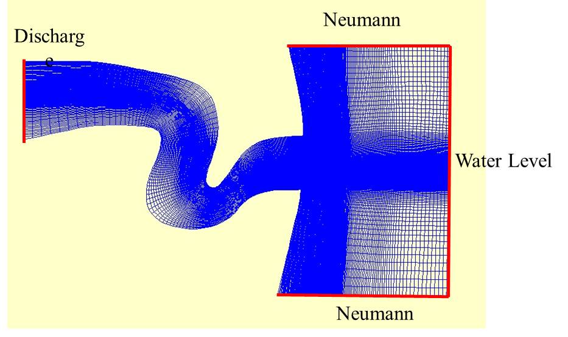

Figure 1. Delft3D-Flow grid and boundary conditions.

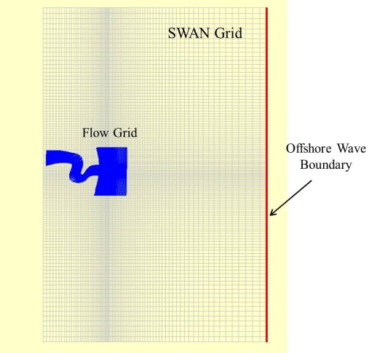

Figure 2. Delft3D-SWAN grid and boundary condition.

FIELD DATA DESCRIPTION AND DELFT3D RESULTS
The geographical location of New River Inlet is located in North Carolina at Latitude: 34.52739 and Longitude: -77.3369 in the southeast coast as is shown in Figure 3. The inlet has two channels and ebb tidal deltas offshore of the inlet entrance. One channel is located on the southwestern side and it has been recently dredged with water depth less than 10 m. The other channel is located at the northeastern side and it is shallower than the other channel with water depth less than 3 m. The inlet channel width is about 200 m and it connects the Atlantic Ocean with the river, for more details see (Chen2015). In order to validate the numerical settings of Delft3D and SWAN, the results of Delft-SWAN model is compared with the field data collected by two research groups: WHOI group by Raubenheimer and Elgar, and SIO from Feddersen and Guza.

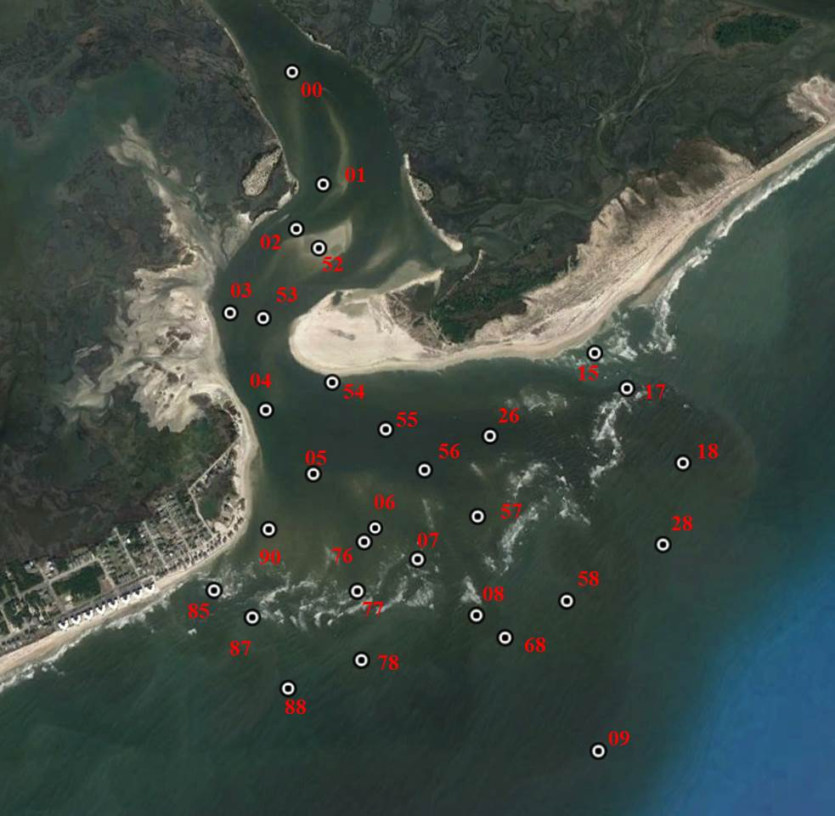

Figure 3. Gauges-WHOI locations at New River Inlet.

Model Performance and Comparison with WHOI Data

The first field data is collected by WHOI group from April 29th 2012 to May 28th 2012. The data presented here can be downloaded from the following link: (http://science.whoi.edu/users/elgar/RI-DRI/index.html). There are two types of pressure gages that have been used to collect data, p-sensors and q-sensors. The p-sensors are placed about 45 cm above the seafloor. The q-sensors are Paros pressure gages and some of them are buried. The sampling rate for this data is 2 Hz for 3072 seconds that start at the top of the hour. In this study, the q-sensors are used to estimate the free surface elevation and/or water depth. There are 28 q-sensors and their locations are shown in Figure 3. The NorTek Aquadopp profiles are used at the inlet mouth at gauges 00, 01, 02, 05, 06, 07, and 08 to obtain the one-min depth-averaged velocity.

The model results and the field data show a transition region that exists between the tidal-current dominant and wave-dominant on the closer ebb delta to the deeper channel between gauges 78 and 76. The wave height predicated at gauge 78 and gauges 76 are shown in Figure 4. The variation in the wave height at gauge 78 occurs over days compared to the variation in wave height at gauge 76 which is relatively tidally modulated. The flow speed is smaller at gauge 78 and it becomes larger at gauge 76. This sharp/rapid transition predicated by the Delft results match the observations in the field data as indicated as well by (Chen 2015). The wave height at gauge 58 is larger than wave height at gauge 5, and flow speed become weaker at gauge 58. The flow speed at gauge 5 is larger and dominated by tides compared to flow speed at gauge 58 as shown in Figure 5.

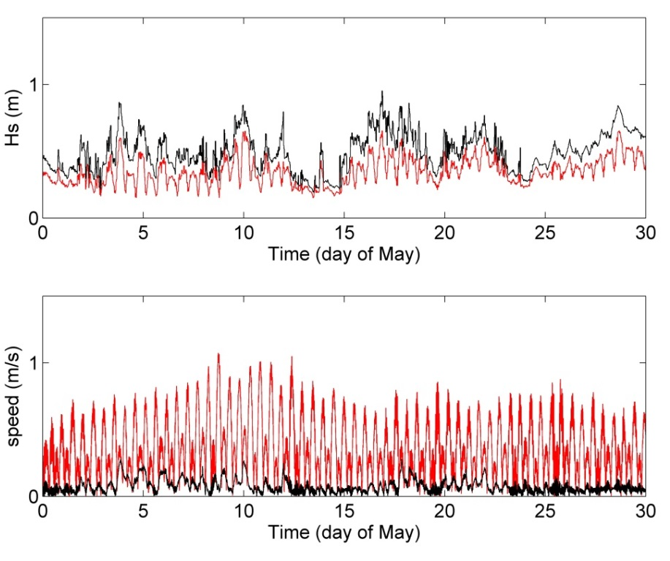

Figure 4. Comparison of wave height in top figure and flow speed in bottom figure at gauges 78 and 76. Red line: gauge 76 and Black line: gauge 78.

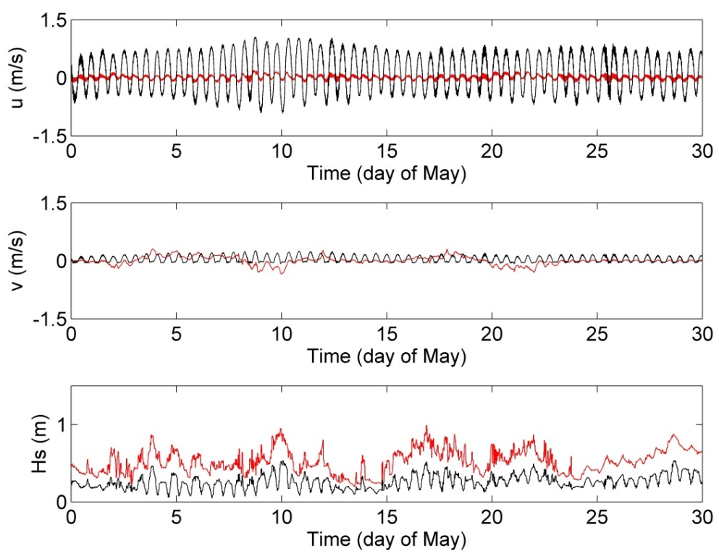

Figure 5. Comparison of velocity-u in top figure, velocity-v in middle figure, and wave height in bottom figure at gauges 58 and 05 from Delft model. Red line: gauge 58 and Black line: gauge 05.
The comparison of Delft3D+SWAN results with WHOI field data for surface elevation is shown in Figure 6 for gauge 68. The model results match the field data very well at most gauges.

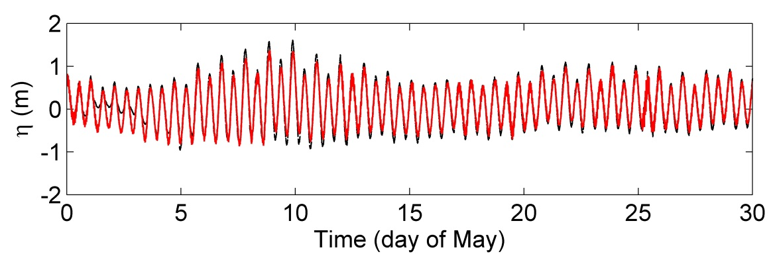

Figure 6. Comparison of water level at gauge-68. Red line: Delft model. Black line: Field data.
The depth averaged velocity comparison is shown in Figure 7 for gauge 00. The comparison of the whole month of May is shown in the top of each figure. Then the comparison is divided into span of 10 days for more clear details. It is noticed that the model results better agree for gauges located inside the inlet, i.e. gauges 00 and 02 compared to gauges close to inlet mouth, i.e., gauges 07 and 08. For gauge 00 and gauge 02, the model results match the field data very well. For gauge 01, the model results reasonably match the available field data. For gauges 05 and 06, the model results slightly under estimate the field data in some days but a good comparison is shown in most days. For gauge 07, the field data is not obtained for the whole month but the model results show reasonable agreement where the data exists. For gauge 08, the model under estimate the field data in the beginning of the month but then it match better towards the end of the month.

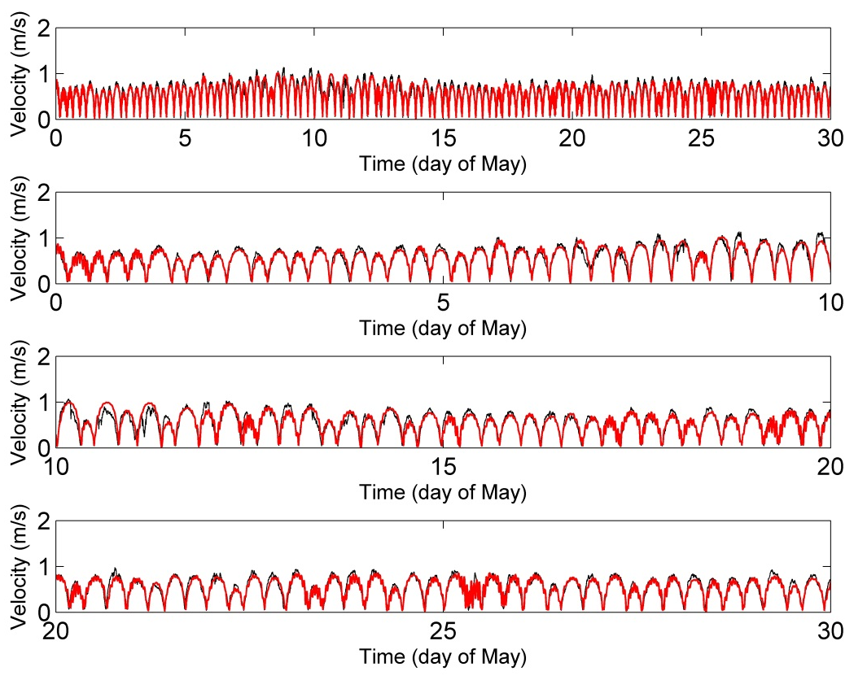

Figure 7. Comparison of one minute depth-averaged velocity at gauge-00. Red line: Delft model. Black line: Field data.

Model Performance and Comparison with SIO Data
The other data set used in this study is the data of SIO from Feddersen and Guza. They have used Rhodamine WT, a non-toxic pink dye to study transport and dispersion in the tidal river inlet. The data is collected from 8 Acoustic Doppler velocimetry (ADV) current meters and 6 Acoustic Doppler Current Profiler (ADCP) with 0.25 Hz sampling rate. The data collection starts from May 1st and ends May 21st. The locations of these ADV and ADCP are shown in Figure 8.

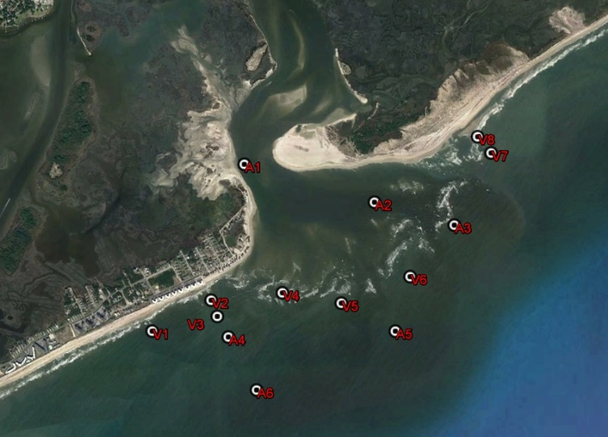

Figure 8. Gauges locations for SIO at New River Inlet.

The comparisons of Delft3D+SWAN results with SIO field data for surface elevation are shown in Figure9 for gauge A1 using the ADCP data. The model results agree very well with the field data at most of the gauges. The model results accuracy is measured with the Wilmott Skill score, (Willmott 2005), following (Chen 2015). This score is defined as

(1)

Where N is the total sample points used in the study, χ is the physical measured quantity, and overbar χ is the mean of the sample. The subscripts (mod) and (obs) represent the modeled values and the observed values. This skill score is between 0 and 1. Where 0 represents no agreement and 1 represent perfect agreement. The model skill score is calculated for all the gauges as mentioned before and the value of, χ=0.99 for all gauges. The model predicts the surface elevation very well at most gauges in the channel and on the ebb deltas. The numerical model skill is slightly lower at gauges 07 and 06 which are located in the outer surf zone where wave refraction is large. The model skill is high for the gauges at the lower bend of the channel but it gets poor at the inner gauges.
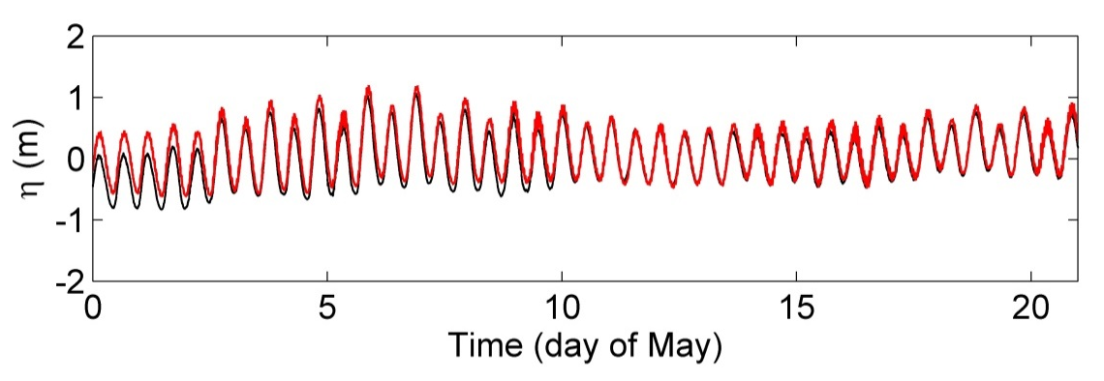
Figure 9. Comparison of water level at gauge-A1. Red line: Delft model. Black line: Field data.

The depth averaged velocity comparison is shown in Figure 10. The comparison of the 21 days of May is shown in the top of each figure. In the same figure, the comparison is then divided into span of 10 days for more clear details. It is noticed that the model results under estimate the field data for most of the gauges. It is shown from the figures that the velocity magnitude is higher in the channel inside the tidal inlet as it reaches 1-2 m/s at gauges A1 and at the outer edge of the ebb tidal deltas at gauges A2. The velocity magnitude decrease rapidly in the offshore direction as it becomes less than 1 m/s at gauges A3 and A4. The minimum velocity magnitude occurs at gauges A5 and A6. The model results match the field data at gauges A1 and A2 and under estimate the field data for the rest of the gauges.

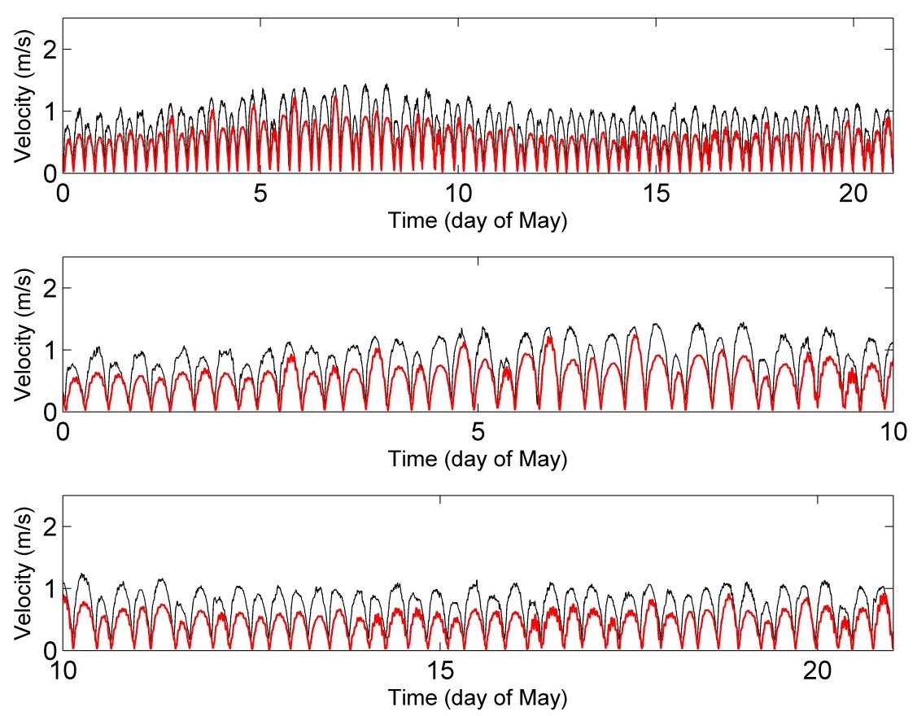

Figure 10. Comparison of one minute depth-averaged velocity at gauge-A1. Red line: Delft model. Black line: Field data.

The comparisons of Delft3d results with the hourly SIO field data of the wave height are shown in Figure 11. The wave height has a maximum value of almost 1 m at most of the gauges. The Delft results under estimate the field data that could be due to wave dissipation from SWAN model calculations.

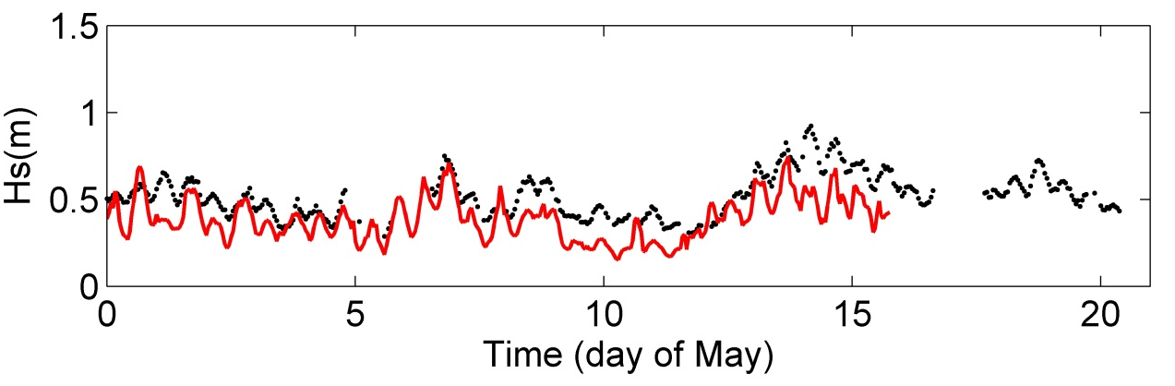
Figure 11. Comparison of significant wave height at gauge-v1. Red line: Delft model. Black line: Field data.

COUPLING BOUESSINESQ-TYPE MODEL WITH DELFT3D-FLOW MODEL: FIELD CASE STUDY OF New River INLET

In this study, the time-domain Boussinesq-type wave model, Coulwave, is coupled with large scale circulation model Delft3D to simulate the waves with the background tidal-current. The current magnitude and direction is extracted from the simulation in Delft3D-Flow only and is used as the external current forcings inside Boussinesq model. The coupling between the two numerical models is done via one-way coupling where only current information is passed to the wave model. The wave-current interaction simulations and comparison with both field data and numerical results of Delft-SWAN are discussed in the following section.

Wave-Current Interaction Results and Discussions
In this section, Coulwave is run for the required time using the wave measured at the coastal data information program CDIP-41109 as offshore forcing. The wave height, peak period, and direction for the month of May 2012 measured at coastal data information program, CDIP-41109, is shown in Figure 12. The buoy is located in water depth of 13 m, about 3.3 nmi from New River Inlet. The wave height is around 2 m most of the month with more energetic wave conditions towards the end of the month on 27 of May. The wave direction is nearly normal to the tidal entrance most of the times.

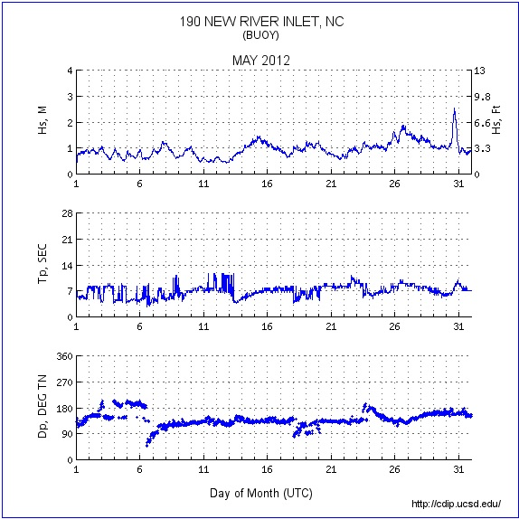

Figure 12. Wave height (m), peak period (sec), and wave direction (degree) measured at New River Inlet buoy.
In the first scenario in this section, the Boussinesq model run with May 11 tides, with high waves of 0.62 m and wave period of 11 sec measured at CDIP-41109. The numerical grid and bathymetry used in Coulwave model is shown in Figure 13. The time-averaged vertical profiles of the horizontal velocities are estimated from coupled wave-current simulation and are compared to the field data gauges of SIO. The comparison of vertical profile of the horizontal velocities with the field data and the vertical profile from Delft-SWAN model for gauge A3 is shown in Figure 14. The vertical profile estimated using the Boussinesq model is better matching the field data compared to the Delft-SWAN model near the bottom. The accurate estimation of the bottom velocity magnitude and skewness is important in sediment transport studies.

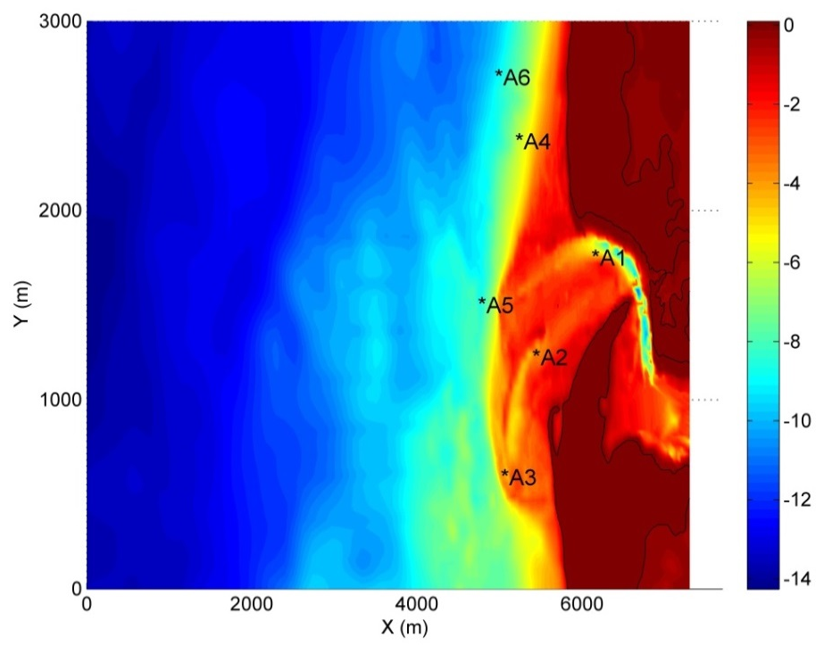

Figure 13. Numerical grid and bathymetry for Coulwave Boussinesq model.

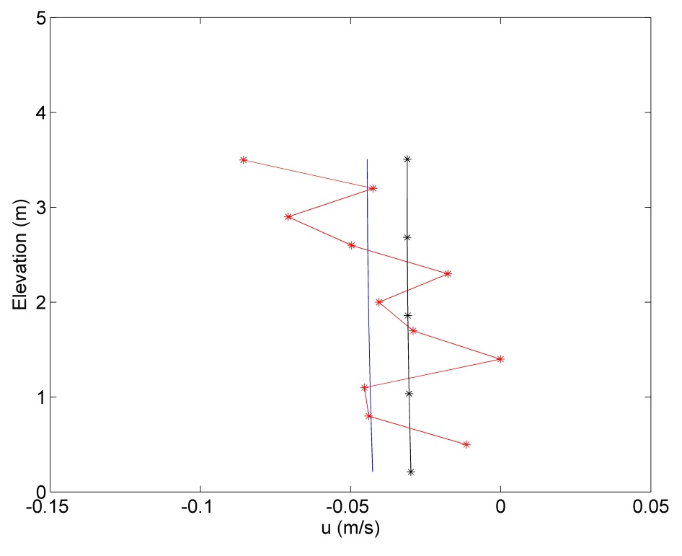
Figure 14. Comparison of vertical profile of horizontal velocity with field data and Delft3D-SWAN at gauge-A3. Red: field data, Blue: Coulwave with Delft-FLOW, and Black: Delft-SWAN

CONCLUSIONS
The current study investigates the wave-current interaction in two dimensions and its application at tidal inlets. At tidal inlets or at river mouth, waves interact with tidal currents and bathymetry. The presence of waves alters the hydrodynamic of the nearshore zone via wave-breaking and wave-current interaction. The difference in length and time scales of the current compared to those of the wave makes it hard to model such complex physical processes using single model. Therefore, we are motivated to develop a "spot-application" tool, where wave-driven processes are simulated in large domains with fine-resolution. To understand the underlying physics of wave-current interaction in such complicated environment and to accurately estimate the fluid kinematics in the breaking zone, an explicit coupling between time-domain phase-resolving Boussinesq-type wave model and a large-scale flow model, Delft3D, is achieved.
A set of depth-integrated Boussinesq equations are derived with background current forcings included. The numerical coupling between Delft3D model and Boussinesq wave model is applied to the field site, New River Inlet located in North Carolina. A one way coupling between the two numerical models is used. Consequently, the same simulation using Delft3D-FLOW model coupled with Delft3D-SWAN model is run. The results of the coupled Delft-Boussinesq and Delft-SWAN are compared for the same simulation.
To validate the numerical settings of Delft3D and SWAN, the results of Delft3D+SWAN model is compared with the field data collected by two research groups. The Delft3D results of surface elevation and depth-averaged velocities matched the field data very well. The field data and the model results show that the inlet channel is dominated by tides and the ebb deltas are dominated by waves. The field data of the time-mean, vertical profile of horizontal velocity measured by ADCP collected at six locations is used to compare the results of the coupled Delft3D-SWAN simulation and the coupled Delft3D-Bouessinesq simulation. The closest ADCP to wave breaking is chosen for comparison as waves get steeper and become highly nonlinear, just before breaking. The coupled time-domain, phase-resolving, Boussinesq model predicts the vertical profile of the horizontal velocity more accurate compared to the spectral wave model. The accurate predication of the coupled Boussinesq model of the fluid kinematics in the breaking zone is important to accurately model different coastal processes such as pollutant transport and mixing, sediment transport, infragravity release and propagation.

ACKNOWLEDGMENTS
Research support for this effort was provided by the Office of Naval Research

REFERENCES
Battjes, J.A., and J.P.F.M. Janssen. 1978. Energy loss and set-up due to breaking of random waves, Proceedings of 14th International Conference on Coastal Engineering, ASCE, 466-480.

De Vriend, H.J., J. Zyserman, J. Nicholson, J.A. Roelvink, P. Pechon, and H.N. Southgate. 1993. Medium-term 2DH coastal area modeling, Coastal Engineering, 21, 193-224.

Wargula, A., Raubenheimer, B., and Elgar, S. 2014. Wave-driven along-channel subtidal flows in a well-mixed ocean inlet. Journal of Geophysical Research: Oceans, 119:2987–3001. doi: 10.1002/2014JC009839.

Bakker, W., and van Doorn, T. 2011. Near-bottom velocities in waves with a current. Coastal Engineering Proceedings, 1(16).

Morelissen, R., Der Kaaij, T., and Bleninger, T. (2013). Dynamic coupling of near field and far field models for simulating effluent discharges. Water Science and Technology, 67(10):2210 – 2220.

Veeramony, J., Condon, A., and Hebert, D. (2012). Effect of coupling wave and flow dynamics on hurricane surge and inundation. Proceedings of the International Offshore and Polar Engineering Conference, pages 1503 – 1507, Rhodes, Greece.

Nardin, W., and Fagherazzi, S. (2012). The effect of wind waves on the development of river mouth bars. Geophysical Research Letters, 39(12).

Elias, E. P. L., Gelfenbaum, G., and Van der Westhuysen, A. J. (2012). Validation of a coupled wave-flow model in a high-energy setting: The mouth of the Columbia river. Journal of Geophysical Research: Oceans, 117(C9):n/a–n/a. doi: 10.1029/2012JC008105. C09011.

Chen, B., Zhu, J., and Li, L. (2012). Accelerating 3d ocean model development by using gpu computing. Lecture Notes in Electrical Engineering, pages 37 – 43, Takamatsu, Japan.

Chen, J.-L., Hsu, T.-J., Shi, F., Raubenheimer, B., and Elgar, S. (2015). Hydrodynamic and sediment transport modeling of new river inlet (nc) under the interaction of tides and waves. Journal of Geophysical Research: Oceans, 120(6):4028 – 47.

Condon, A., and Veeramony, J. (2012//). Development and validation of a coastal surge and inundation prediction system. pages 8 pp. –, Piscataway, NJ, USA.

Soulsby, R., Hamm, L., Klopman, G., Myrhaug, D., Simons, R., and Thomas, G. (1993).Wave-current interaction within and outside the bottom boundary layer. Coastal Engineering,
21(1-3):41 – 69.

Swan, C. (1990). An experimental study of waves on a strongly sheared current profile. volume 1, pages 489 – 502, Delft, Neth.

Civil Engineering, University of Southern California,3260 s Vermont avenue, Los Angeles, Ca, 90007.
Civil Engineering, University of Southern California,3260 s Vermont avenue, Los Angeles, Ca, 90007.

