MODELLING LONG-TERM SHORELINE EVOLUTION: FIGUEIRA DA FOZ BEACH, PORTUGAL
Carla Pereira, Carlos Coelho and Paulo A. Silva
This work applies two different shoreline evolution numerical models (LTC and GENESIS) in two different time periods (1980-2010 and 2010-2014) to compare respectively the calibration and validation performance of the models. The models were applied to evaluate long-term shoreline position and longshore sediments transport evolution, considering as a case study a sandy beach stretch located updrift of the Figueira da Foz harbor jetty, on the Northwest Portuguese coast. Due to the jetty extension, this stretch exhibits a clear accretion trend during the analyzed time periods. For this region, the longshore sediment transport rate estimated by several authors varies between 200 and 1500x10³m³/year. According to the modelling results, it was observed that both models reproduce reasonably well the shoreline evolution between 1980 and 2010. In average, the LTC model reproduces a 2010 shoreline position nearest the observed and GENESIS presents better approximation in the Northern part of the beach and also near the South (downdrift) border (just close to the Northern jetty of the harbor). The modeled shoreline average accretion rates for the considered stretch is quite similar and close to the values referred in the bibliography, which indicates that the beach presents 500 meters of maximum accretion width updrift the jetty (about 16.6m/year). In what concerns to the longshore sediment transport it was observed that numerical models generally indicate lower values than the bibliography, being GENESIS results higher and closer to the observed than the LTC. These results are common in the numerical modelling of shoreline evolution, showing that is difficult to simultaneously represent both the shoreline position and sediment transport volumes. After calibration, LTC validation was evaluated for the time period between 2010 and 2014 to allow confidence in the extrapolation of results to the future. Estimated deposition rates of about 350x10³m³/year were obtained at the harbor entrance.
Keywords: numerical models, longshore sediment transport, accretion rates, jetty, calibration and validation

INTRODUCTION
Commonly, the jetties at harbor entrances are coastal structures that promote important impacts in the shoreline evolution and in the morphdynamics and sediments dynamics of a coastal stretch. Thus, this study developed an analysis at the updrift side of a jetty located in Portuguese NW coast, aiming to numerically characterize the shoreline position accretion rates and estimate the longshore sediment transport rates at Figueira da Foz beach, updrift the harbor. To achieve these goals, it was necessary to understand the sediment dynamics at the coastal stretch between the Mondego Cape and the Mondego inlet, features that limit the beach under study (Figure 1). Bibliographic review was made and the study area was characterized in relation to shoreline position along time and sediment transport rates evolution. This work is part of a major goal that aim to study and understand the sediment dynamics at the Mondego inlet and surrounding areas and define a dredging plan that: i) allow navigability conditions at the inlet and navigation channel, for the typical wave climate conditions; ii) maintain the littoral drift conditions by deposition of the dredging material at South of the inlet.
Two shoreline evolution numerical models which simulate the hydrodynamics and morphdynamic: GENESIS (Hanson and Kraus, 1991) and LTC: Long-Term Configuration (Coelho, 2005), were applied. Numerical models can establish trends and project future scenarios and can be validated by simple observation of actual behavior of natural systems under the influence of a certain wave climate, mean sea level, coastal defense works, etc. These models have been previously applied simultaneously by Coelho et al. (2013) and Baptista et al. (2014).
In this study, the numerical models were calibrated in order to represent the shoreline evolution in a 30 years’ time period, between 1980 and 2010. To do this it was used a wave climate series with 30 years of record: 1971-2000, that was determined based on the application of the WW3 wave model to the North Atlantic (Ribeiro et al., 2012). Another consideration made was about the shoreline position in the calibration process. It was considered as the initial shoreline position the one surveyed in 1996 as representative to the 1980's shoreline (initial shoreline position on model simulations).
After the calibration process, a validation of the modeling processes was performed for the period 2010-2014. In the validation process the wave series used correspond to observed records of the buoy located at Leixões, about 120km at North of the study area.
The longitudinal sediment transport resulted from the numerical models was analyzed and discussed in the light of the values described in the literature. Evaluation and comparison of results obtained for both models was made.

CHARACTERIZATION OF THE STUDY AREA
The Figueira da Foz beach is located at the North side of the mouth of the Mondego River, in the district of Coimbra, Portugal. The study area is located in a coastal stretch with two different morphdynamic characteristics. The area between Mondego Cape and Buarcos beach with a length of about 5km, with semi-recessed beaches and the South sector between Buarcos and Figueira da Foz beach characterized by the existence of a sandy beach (Figure 1). With a slightly curvilinear shape, Figueira da Foz beach is about 2km long and between 200m and 500m wide.
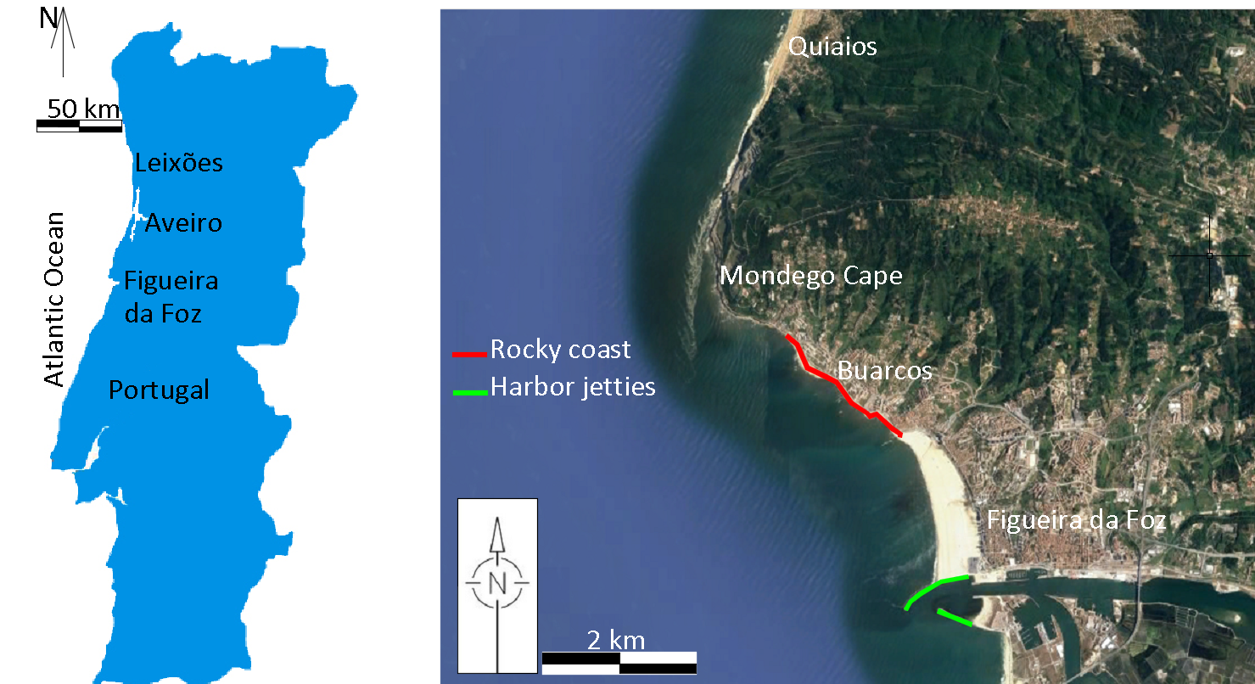
Figure 1. Study area location: a) Portugal; b) Figueira da Foz beach.

Historically the Figueira da Foz harbor located in the mouth of the river is related to the growth of the city. The construction of the Figueira da Foz harbor jetties had a strong impact on the morphology of the coastal area both at North and South of the inlet. The construction of two jetties was concluded in 1965, one at North and one at South of the mouth, with 900m and 950m lengths, respectively, which set the Figueira da Foz harbor inlet. Between 2008 and 2010 the Northern jetty was extended by 400m in works carried out to minimize the problems that affected the navigability of the harbor, including the silting of the bar and the navigation channel and reduce the wave climate energy in the commercial harbor area (Almeida and Seabra-Santos, 1994; Agri-Pro, 2004).
The Figueira da Foz harbor presents recurrent silting problems at the harbor inlet. To restore proper connection, dredging operations has been carried out in this area. Table 1 shows the values of sediment volumes dredged since 2002.

Table 1. Dredged sediments volume at Figueira da Foz inlet.
Year | 2002 | 2003 | 2004 | 2005 | 2006 | 2007 | 2008 | 2009 | 2010 | 2011 | 2012 | 2013 | 2014 | 2015
Dredged volume (x10⁶) m³ | 0.49 | 0.53 | 0.38 | 0.45 | 0.49 | 0.39 | 0.25 | 0.12 | 0.05 | 0.18 | 0.10 | 0.26 | 0.11 | 0.11

Wave Climate
The Portuguese Northwest coastal area is characterized by a mean tidal range of 2.2m and a very energetic wave climate, with the incident wave direction mostly approaching from Northwest and presenting large winter/summer seasonality. In the Figure 2 it is shown the wave climate refereed to different data recorded at Leixões and Figueira da Foz buoys. According to Freire et al. (2004), in the winter the wave direction rotates slightly to West and in summer it rotates to North. Higher significant wave heights are in the West-Northwest quadrant. The average number of storm events per year is 10.5 with time duration lower than two days (75% of the storms). Storm dominant wave direction is from Northwest (58%) and West (13%). Capitão et al. (1997), based on offshore wave records performed between January 1984 and December 1996, indicates that frequently the waves near the Figueira da Foz are coming from N270-300º sector. Significant wave heights greater than 4m were observed only in 2.6% of the total cases of which the maximum values are not superior to 7.5m. Freire et al. (2004) observed a rotation of the direction of wave propagation to the West quadrant between August 2001 and August 2002: the direction of the offshore waves between N185º-N340º is reduced in the coastal area to N200º-N330º, with more frequent values in sector N260º-N330º, which corroborates the former study. It is observed a slight decrease in the wave heights. It is verified that the higher waves (Hs>4m) exhibit little directional dispersion along the coast and its direction is centered around N270º which contrasts with the regime offshore that displays values for the direction of between N270º and N300º.
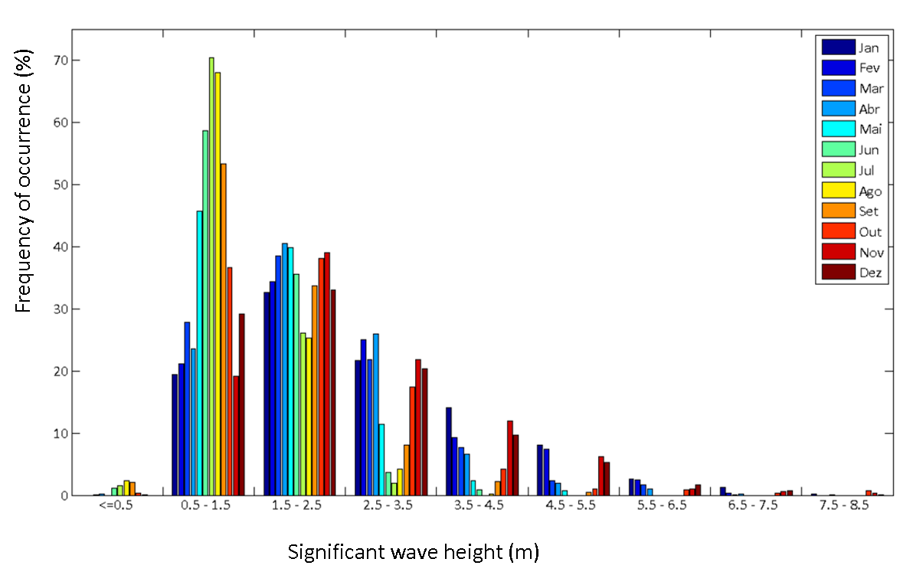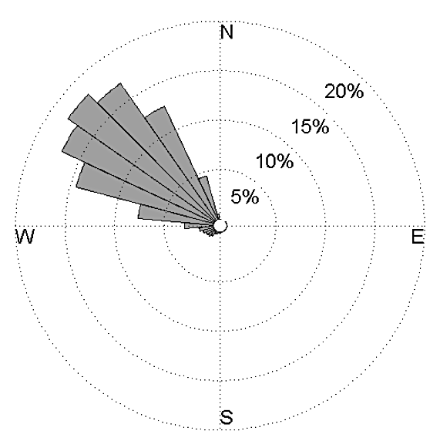
Figure 2. Significant wave height monthly distribution (left), and wave direction rose (right). Data recorded at the Figueira da Foz (1990-1996) and Leixões (1996-2003) buoys.

The shoreline evolution depends on the time series of wave events considered during the simulation. To simulate 30 years of shoreline evolution (1980-2010) was considered a data series of 30 years of wave climate offshore records. The applied wave regime was determined based on the application of the WW3 wave model to the North Atlantic (Ribeiro et al., 2012) in the period between 1971 and 2000. This wave climate is based on the work of Dodet et al. (2010), and the model was originally calibrated with the Leixões buoy data, available for the Portuguese West coast. The calibrated model was then forced with winds obtained from reanalysis. The scenario was forced by wind fields generated by the climatic model ECHAM5. The wave climate that was used in the models considered time series, with records every 6 hours. Tables 2 and 3 show the representative wave class distributions of heights and directions. For the simulation period between 2010 and 2014, the observed records at the Leixões buoy were considered.

Table 2. Wave heights distribution for the period 1971-2000, based on WW3 wave model.
Hs (m) | 0.0-1.0 | 1.0-2.0 | 2.0-3.0 | 3.0-4.0 | 4.0-5.0 | 5.0-6.0 | 6.0-7.0 | 7.0-8.0 | 8.0-9.0 | 9.0-10.0
Wave climate | 14.4 | 46.3 | 23.5 | 10.0 | 3.9 | 1.3 | 0.5 | 0.1 | 0.0 | 0.0

Table 3. Wave direction distribution for the period 1971-2000, based on WW3 wave model.
Direction | NNW | NW | WNW | W | WSW | SW | SSW
Wave climate | 7.3 | 20.5 | 33.9 | 25.9 | 8.2 | 2.9 | 1.3

Longitudinal Sediment Transport and Accretion Rates
Due to the particular importance of the Mondego Cape feature, located at the upper limit of the study area, the analysis of longitudinal sediment transport, which takes place predominantly from North to South, is a case study difficult to evaluate. Thus, past studies on sediment dynamics in the coastal area focused mainly on the morphological evolution of the beaches of Buarcos and Figueira da Foz, in response to the construction and extension of the harbor jetties of Figueira da Foz. Those studies made some estimative of the longitudinal sediments transport rates and evaluated the origin of the sediments that feed the Figueira da Foz coastal system.
Ferreira (1993) states that the accumulation of sand against the harbor's north jetty cannot be justified by any sedimentary local source between Quiaios and the Mondego's inlet, because the shoreline is characterized by steep cliffs on calcareous, without turnout of any river. The sediments that feed this sector come from the sector located at North of Mondego Cape. Abecasis et al. (1962) reported an experiment carried out with marked sands by radioactive elements, which were released on the beach of Quiaios, showing that the sediments from North littoral drift cross the Mondego Cape. Different estimates were made for this transport based on retention of sediments at the North jetty (Table 4).

Table 4. Longitudinal sediment transport at Figueira da Foz.
(x10⁶m³/year) | Reference
1.0 | Vicente and Clímaco (1986)
0.9 | Dias et al. (1994)
0.89 | Oliveira et al. (2002)
0.79-1.54 | Larangeiro et al. (2003)

The intense sediment transport mostly associated with storm conditions creates a submerged bar at the inlet, which is persistent even after dredging works at the inlet, and for an increase of Figueira da Foz beach width: between 1962 and 1980 the width of the beach has increased by about 440m along the Northern breakwater and about 180m at the North end of the beach, near Buarcos.

SHORELINE EVOLUTION AND SEDIMENTS TRANSPORT - NUMERICAL MODELS
The shoreline evolution numerical models can establish trends and project future scenarios, and can be validated by the simple observation of the actual behavior of natural systems under the influence of a certain wave climate, mean sea level, coastal defense works, etc. The simplest theoretical numerical model is based on the analysis of sedimentary balance at a particular time interval. If the volume of sediments that gets into the coastal stretch cell is greater than the volume of sediments going out, accretion is observed, otherwise, an erosion trend is obtained. A great difficulty in the use of numerical models is to establish boundary conditions, calibration coefficients and parameters associated with variables that represent the reality of the system and contribute to correctly modeling the registered processes.

Numerical Models
Two types of shoreline evolution models were applied in the developed study: GENESIS (Hanson and Kraus, 1991) and LTC: Long-Term Configuration (Coelho, 2005). In GENESIS, spatial and temporal differences in the sediment transport rate may be caused by a range of diverse factors such as wave propagation due to irregular bottom bathymetry, wave diffraction, boundary conditions, sources and sinks of sediments and sediment transport constraints (such as those produced by seawalls and groins), all of which are factors that are interrelated and may function in different combinations at different times. The modelling system is generalized to a wide variety of offshore wave inputs, initial beach plan shape configurations, coastal structures and beach fills (Hanson and Kraus, 1991). The LTC model is specially designed for open sandy beaches, where the main cause of shoreline evolution is also longshore sediment transport gradients, which is dependent on the wave climate, water levels, sediment sources and sinks, sediment characteristics and boundary conditions. Moreover, different combinations of coastal interventions (groins, longshore revetments, artificial nourishments, etc.) may be considered (Silva et al., 2007, Coelho et al., 2009 and Roebeling et al., 2011). The model is able to uniformly distribute erosion or accretion resulting from gradients in alongshore sediment transport along the active cross-shore profiles, between the depth of closure (DoC) and the wave run-up limit.
The key difference between GENESIS and LTC is the LTC ability to update the active cross-shore profile along the calculations (Coelho et al., 2007, Silva et al., 2011 and Coelho et al., 2013), while GENESIS maintains the cross-shore profile shape assumed as constant. Near cross-shore profile boundaries, LTC allows geometrical considerations related to slope angles that may be adopted to define profile evolution (Figure 3). LTC has to consider a more streamlined wave propagation process since in each time step the bathymetry changes due to the sediment transport gradients. GENESIS uses wave information defined through STWAVE that is a half-plane model in the sense that it only includes spectral energy directed into the computational grid at the seaward boundary GENESIS (Hanson and Kraus, 1991).
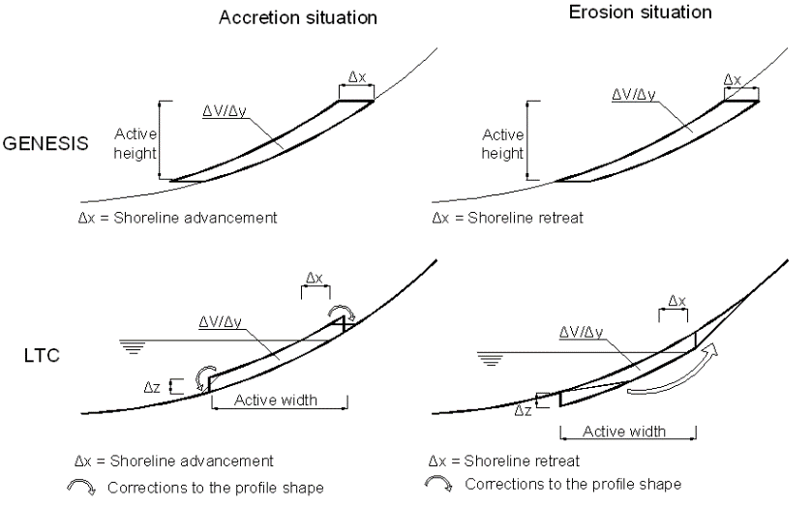
Figure 3. Schematic representation of the differences between GENESIS and LTC (Coelho et al., 2013).

Spatial Domain
The bathymetric data used to define the spatial domain to numerically model the study area was obtained from an offshore Fishing Chart of the Portuguese Hydrographic Institute (chart number 24202), and was associated to extended topographic data available from an aero-photogrammetric survey, conducted in 1996, by the Army Geographic Institute (military charts number: 227B, 228, 238A and 239). Shoreline was obtained by intersecting the mean sea water level with the coastal topography (elevation +2.0m CD). The shoreline in 1980 was considered as the initial shoreline position for modelling, as an approximation to the cartographic 1996 position.
The spatial domain for modelling was represented by a regular grid of points with a resolution of 100x75m² in a total extension of 35x5km². The existing coastal defense works at the study site were included in the numerical models, after all the necessary considerations related to their position, wave propagation effects and permeability, allowing to establish the most appropriate calibration results. For GENESIS, the definition of the depth of closure and berm height was required, corresponding to 12m and 4m, respectively. In LTC, the depth of closure is calculated internally along the simulation, according to the Hallermeier (1978) formulation. The characteristic median sediment grain size, D50, was set to 0.3mm for the entire study area and for both models. Table 5 shows the adopted values for the parameters that comprise the modeling process. The considered values refer to the study area characteristics and are relevant to numerical simulations. Some parameters were test target and changed, during the calibration process.

METHODOLOGY
The methodology used in this study is characterized by two phases, corresponding to models calibration and posterior validation. In the calibration process was attempted to approach the numerical simulation results to what has been the observed shoreline evolution and sediment transport volumes between 1980 and 2010. These two parameters (shoreline accretion rates and longitudinal sediment transport volumes) are difficult to calibrate simultaneously as observed in previous studies (Baptista et al., 2014). To validate the calibration setup, a shorter time interval was considered, 2010-2014, in which were compared the modeled results with the shoreline position in 2014.

Table 5. Adopted values for the parameters considered in the numerical models.
Median sediment grain size (D50) | 0.3mm
Seawater density | 1027kg/m³
Kinematic water viscosity coefficient | 1.36×10⁻⁶m²/s
Sediments density | 2650kg/m³
Sediments porosity | 0.4
CERC coefficient | 0.005
Sediments shear stress angle | 20º
Berm high | 4m
D_{o}C | 12m
Wave breaking depth coefficient | 0.78

Calibration
Several tests were made by varying numerical parameters associated with internal modeling formulations, aiming to obtain the best calibration for both models. Along this process, the shoreline position was evaluated, allowing the analysis of the corresponding accretion rates. The sediment transport volumes were also estimated. There was some difficulty calibrating the LTC model, due to the existence of Mondego Cape, which could induce diffraction phenomena that were not well reproduced by the model. Thus, during the calibration tests the wave direction was considered as a calibration factor. Thus, to reproduce the diffraction effect that Mondego Cape promotes in the wave characteristics, a slight rotation in wave direction was tested, thereby enabling to adjust the wave to the diffraction phenomenon that occurs in reality.
Being known the shoreline position in 2010, the simulations of the shoreline evolution in the previous 30 years were done (1980-2010) trying to get through modeling, the known shoreline position in 2010. Do to this, the initial shoreline position was based on the shoreline in 1996 (year of the survey available) and adapted to better represent an approximation to the 1980 shoreline. In order to model simulation between 1980 and 2010, the wave climate series representing the years 1971-2000 (as described in the Wave Climate section) was used in order to apply a wave climate that represent 30 consecutive years of records.
For both models, the calibration process tried to evaluate the shoreline position variation rates and sediment transport volumes along the Figueira da Foz beach for the time period between 1980 and 2010, considering the difference between the initial shoreline position and the final shoreline position estimated based on satellite images. After the construction of the harbor jetties, between 1962 and 1980, has been observed the accumulation of sediments on the beach of Figueira da Foz and the width of the beach has increased by about 440m along the breakwater and 180m at the North end next to Buarcos. The accretion rate (440m/18years) has slightly decreased in the following years, being estimated in an average rate of 500m in 30 years after the breakwaters construction. This accretion should be represented at this stage of the calibration.
In order to get the best possible calibration all parameters required by GENESIS and LTC models were tested by running various simulations. However, simulations for long periods are difficult to design, as that may contribute for numerical instabilities during progress calculation over time. For all the scenarios, the best performance models were evaluated.

Validation
In order to make a validation of the results obtained through the numerical models after calibration, a validation test was performed. The simulation of the shoreline position evolution since 2010 until the year 2014 was made, to compare the results obtained by the models with the observed shoreline position in 2014. The shoreline considered for comparison in 2014, corresponding to the end of the numerical run for validation, was the shoreline obtained by satellite image.
For the validation period the model domain was the same as in the period between 1980 and 2010, but in this case was considered the 400m extension of the North jetty of the Figueira da Foz harbor, increasing the extent of the jetty in the modeling process. The initial shoreline for these simulations was the final shoreline position obtained during the calibration process, also considering the parameters set in the calibration process. The wave climate that forced the model was the observed one, registered by the Leixões buoy for the period between January 2010 and November 2014.

RESULTS
The results obtained in the calibration and validation processes, are presented in the following section. During these two phases of the modelling process, special attention was given to the shoreline position projections for 2010 and 2014, and the longshore sediment transport volumes crossing three control cross-sections at Figueira da Foz beach, located at the Northern and Southern borders and also in the middle extension of the beach.

Calibration
During the calibration process, three different tests were carried out: considering the wave climate without any wave direction rotation, and then, considering a 10 degrees rotation and 20 degrees rotation in the counterclockwise direction. The shoreline position was evaluated for each of the scenarios, as shown in Figure 4. Shoreline position evolution and the sediment transport volumes were analyzed according to the presented in Table 6.
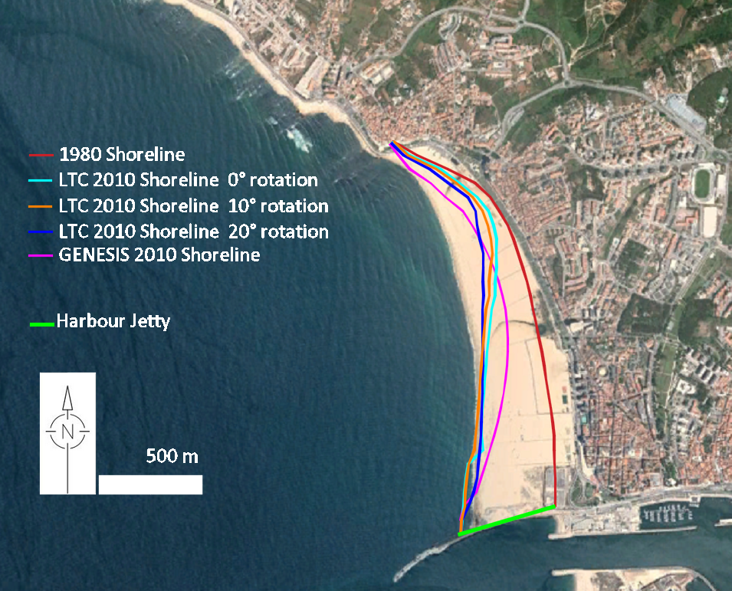
Figure 4. Shoreline projection for the year 2010 (about aerial photography of 2010).

Table 6. Shoreline position in the calibration process (1980-2010).
 | LTC (wave climate rotation clockwise) |  |  | GENESIS
 | 0° | 10° | 20° | GENESIS
Average accretion (m/year) | 8.91 | 9.77 | 9.80 | 8.72
Accretion in the jetty neighborhood (m/year) | 16.29 | 16.15 | 15.39 | 16.59

Both models estimated accretion on the beach, being the average rate along the beach of around 9m/year, which is higher immediately at North of the jetty, with accretion of about 16m/year. Considering the different LTC results for various wave climate rotations, it is observed that by increasing the rotation also increases the average accretion of the shoreline position along the beach, in spite of the lower advances of the shoreline near the jetty. The longshore sediment transport volumes were analyzed in three cross sections (Table 7). The cross sections adopted to control the transport volumes were the Northern and Southern borders of the study area and a central section, representing the beach of Figueira da Foz. Due to the wave climate variability, sediment transport volumes were analyzed in both directions: from North to South and South to North, allowing the evaluation of the net littoral drift.
Table 7 shows smaller values than the ones described in the literature. In LTC model, by increasing the rotation of the wave climate, transport rates decreases. The GENESIS model present higher sediment transport volumes than LTC numerical model. LTC model presents the higher values in the middle of the coastal stretch, at Figueira da Foz beach while GENESIS present a decrease of the sediment transport volumes along the coastal stretch, from North to South.
Table 7. Longshore sediment transport (x10³m³/year) at the control sections (1980-2010).
Control sections | LTC |  |  |  |  |  |  |  |  | GENESIS
Control sections | N-S |  |  | S-N |  |  | Net |  |  | N-S | S-N | Net
Control sections | 0º | 10º | 20º | 0º | 10º | 20º | 0º | 10º | 20º | N-S | S-N | Net
Northern border | 133 | 113 | 88 | 11 | 17 | 27 | 123 | 96 | 61 | 262 | 117 | 145
Figueira da Foz Beach | 139 | 125 | 109 | 10 | 15 | 20 | 129 | 111 | 88 | 206 | 77 | 129
Southern border | 95 | 71 | 52 | 2 | 3 | 5 | 92 | 68 | 48 | 177 | 69 | 108

After the calibration process, it was considered that the best calibration conditions for LTC model correspond to the rotation of the wave direction, with an angle of 20⁰. Sediment transport rates are in the same magnitude of the values resulting from the inlet modeling and Southern stretch. This scenario was adopted for the validation process, along the time interval of 2010-2014.

Validation
After calibration, the simulation of the shoreline evolution was performed for the period between 2010 and 2014 applying the LTC model and extending the Northern breakwater in 400m, noting that the beach keeps the trend of accretion in this stretch (Figure 5).
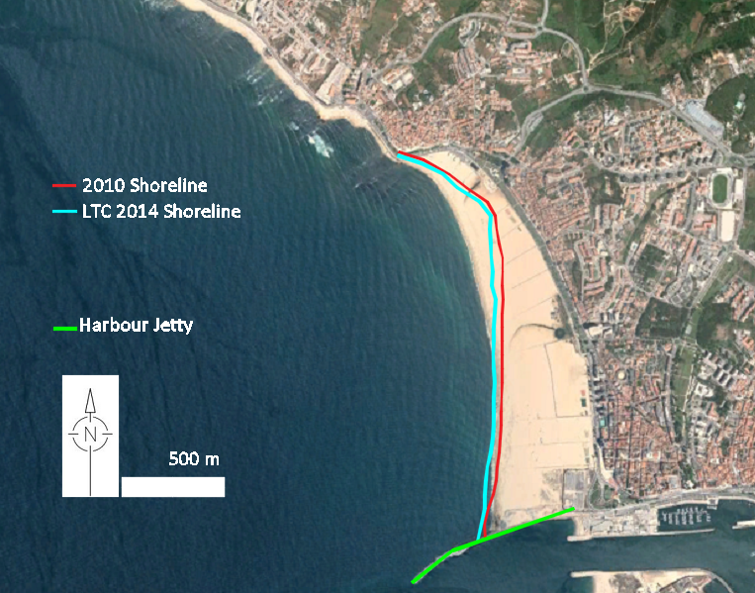
Figure 5. Shoreline projection for the year 2014 (on aerial photography of 2010).

Table 8 shows the shoreline accretion rates along this stretch for the period 2010 2014, following the trend between 1980 and 2010. Due to the harbor breakwater extension, the accretion rate, near the jetty slightly increased when compared to the 1980-2010 period. However, the average accretion at the beach stretch presented a slightly decrease.

Table 8. Shoreline position in the validation process (2010-2014).
Shoreline position | LTC
Average accretion (m/year) | 9.44
Accretion in the jetty neighborhood (m/year) | 16.23

Table 9 shows the analysis of the longshore sediment transport volumes for the same cross sections of the calibration process, for the 2010-2014 time interval. The obtained results are similar to the obtained for the period 1980-2010, being significantly lower than the values reported in literature.
Performing a correction to the modelled sediment fluxes, trying to estimate a valid relationship between numerical model results and bibliographic references, a coefficient of about 12 was applied. Considering this, between 1980 and 2010 the longitudinal sediment transport volume results at Figueira da Foz beach would be estimated in about 792x10³ to 924x10³m³/year by LTC and 1524x10³ to 1778x10³m³/year by GENESIS. At South of harbor inlet, the result would be between 540x10³ and 630x10³m³/year (LTC). Thus, the net balance between North and South coastal stretches are around 250x10³ to 300x10³m³/year, which is considered in accordance with the deposition rates at the inlet. However, for the validation period it was observed a variation of about 350x10³m³/year in the sediment transport volume balance between the North and the South coastal stretches. It has been assumed that this volume is related to the presence of the underwater bar at the inlet (that demands the need of dredging operations).

Table 9. Longshore sediment transport (x10³m³/year) at the control sections (2010-2014).
Control sections | LTC
Control sections | N-S | S-N | Net
Northern border | 87 | 27 | 59
Figueira da Foz Beach | 107 | 20 | 87
Southern border | 53 | 4 | 49

DISCUSSION
Shoreline evolution simulations performed by the numerical models were forced with time series of wave climate records. These simulations were calibrated in order to get the best ratio between the sediment transport volumes and the shoreline position corresponding to the observed situation in 2010. Previous studies showed that it is extremely difficult to simultaneously obtain good results for the numerical simulation of the sediment transport volumes and the shoreline position (Pereira et al., 2013 and Baptista et al., 2014). Main attention was given to the shoreline position and thus, sediment transport volumes presented much lower rates than the values reported in the literature for the coastal stretch under analysis. Oliveira et al. (2002) indicate the value of 890x10³m³/year of net sediment transport at the beach of Figueira da Foz. In an attempt to find a valid link between the values obtained by numerical modeling and the literature, it is considered reasonable to indicate that the first ones are 12 to 14 times lower. Given this assumption, the average values of net sediment transport volumes obtained for the period considered in the calibration process (1980-2010) may indicate that the longshore sediment transport representing the dynamics of the Figueira da Foz beach is comprised between 792x10³ and 924x10³m³/year for LTC and 1524x10³ and 1778x10³m³/year for GENESIS.
Considering the same analysis of sediment transport volumes to the validation period between 2010 and 2014, values between 780x10³ and 910x10³m³/year were obtained, being quite close to the values obtained for the calibration period. This analysis may represent that the impact of the extension of the breakwater in the longshore sediment transport of the Figueira da Foz beach is reduced. However, the values of the net longshore sediment transported are variable along the coast. According to different authors, the beaches located at South of the Mondego river mouth and outside the region disturbed by the Mondego Cape and harbor jetties are referenced between 1.0 and 2.0x10⁶m³/year. At the Figueira da Foz beach the littoral drift feeding the Southern sector has lower values, being around 420x10³m³/year (eg. Cunha and Dinis, 1998).

CONCLUSIONS
In the first stage of this study it was performed a detailed characterization of the mechanisms associated with the morphological evolution of the study area, in particular considering the North jetty 400m extension work performed in 2008-2010. To this end, it was developed the definition, characterization and diagnosis of the study area related to its historical evolution, longshore sediment transport rates and wave climate characteristics. This information was relevant in the description of sediment dynamics in the study area.
The numerical models LTC and GENESIS were used to reproduce the evolution of the shoreline position and to analyze sediment volumes in transport in the coastal stretch that comprises the study area. In spite of similar average results, both models presented significant differences and require appropriate treatment. Both models reproduce reasonably well the shoreline evolution between 1980 and 2010. In average, the LTC model reproduces a 2010 shoreline position nearest the observed and GENESIS presents better approximation in the Northern part of the beach and also near the South (downdrift) border (just close to the Northern jetty of the harbor). Average shoreline accretion rates are in the order of magnitude of the observed in the time periods under analysis. The rates obtained through the numerical modeling point out to approximately 16m/year. The values referred in the bibliography indicate that the beach presents 500 meters of maximum accretion width updrift the jetty, between 1962 and 1992 (about 16.6m/year).
By observing the modeled sediment transport values obtained by the models and comparing them with the values presented in Table 4, it can be concluded that the modeled values are of a lower order of magnitude than the observed sediment volumes in transport requiring the application of a correction factor. Despite the assessment of transport sediment volumes require the application of a factor value for adjustment proportional to the reference values for the study area, there was a trend towards higher volumes to achieve the Mondego river mouth from North, than those which are then transported to the South of the mouth, which indicates the propensity to sediment deposition in the bar, at the entrance of the estuary, at the estimated rate of 350x10³m³/year.
Finally, it is referred that important difficulties in correctly represent shoreline accretion rates and longshore sediment transport volumes reduce confidence in quantitative evaluations. However, several tasks are under development to better represent the sediment dynamics at the study site that will conduct to a qualitative analysis of different deposition scenarios at South, in order to mitigate coastal erosion problems (volumes, location, frequencies).

ACKNOWLEDGMENTS
Information made available by Figueira da Foz Harbor Administration was appreciated. Collaboration with all the elements of the project team, namely Ángela Fontan Bouzas, Caroline Ferreira, João Miguel Dias, Nuno Vaz, Cristina Bernardes, Lucas Terres, Luís Menezes Pinheiro, Paulo Renato Baptista and Tiago Abreu was fundamental to achieve the project goals.

REFERENCES
Abecasis, F., Matias, M.F., Carvalho, J.J., Vera-Cruz, D. 1962. Methods of determining sand and silt movement along the coast, in estuaries and in maritime rivers. Lab. Nac. Eng. Civil. Technical paper nº 186, Lisboa, 25p.
Agri-Pro. 2004. Estudo de impacte ambiental do projecto das obras de melhoria das condições de abrigo no cais do sector comercial e de manutenção do canal de acesso ao porto da Figueira da Foz, Agri-Pro Ambiente - Estudo Prévio.
Almeida, J.L., Seabra-Santos, F. 1994. Numerical modelling of the “Mareta” wave in Figueira da Foz Port, Seminário Luso-Francês de modelação em hidráulica marítima, Coimbra, Portugal, 103-114.
Baptista, P., Coelho, C., Pereira, C., Bernardes, C., Veloso Gomes, F. 2014. Beach Morphology and Shoreline Evolution: Monitoring and Modeling Medium-Term Responses (Portuguese NW Coast Study Site), Coastal Engineering Journal, Elsevier, 84: 23-37.
Capitão, R.P., Fortes, C.J., Carvalho, M.M. 1997. Coastal dynamic analysis on the stretch Cape Mondego - Mondego Estuary. Erosions at Buarcos. Sea wave study. Report 167/97 NPP, LNEC, Lisboa, 28p.
Coelho, C. 2005. Riscos de Exposição de Frentes Urbanas para Diferentes Intervenções de Defesa Costeira, Ph.D. thesis, Universidade de Aveiro, 404p.
Coelho, C., Veloso-Gomes, F., Silva. R. 2007. Shoreline coastal evolution model: two Portuguese case studies, Proceedings of the 30th International Conference, 3430–3771.
Coelho, C., Silva, R., Veloso-Gomes, F., Taveira-Pinto, F. 2009. Potential Impacts of Climate Change on NW Portuguese Coastal Zones, ICES Journal of Marine Science, 66: 1497–1507.
Coelho, C., Lima, M., Veloso-Gomes, F. 2013. Relationship between cross-shore active profile and one-line shoreline evolution models performance, Journal of Coastal Research, SI65, 2107-2112.
Cunha, P.P., Dinis, J. 1998. Beach erosion between cabo Mondego and Figueira da Foz (Portugal Midwest), from 1995 to 1998. Territorium, 5, 31-50.
Dias, J.A., Ferreira, O., Pereira, A.R. 1994. Estudo sintético de diagnóstico da geomorfologia e da dinâmica sedimentar dos troços costeiros entre Espinho e Nazaré. Edição eletrónica de 2005: w3.ualg.pt/~jdias/JAD/ebooks.
Dodet, G., Bertin, X., Taborda, R. 2010. Wave climate variability in the North-East Atlantic Ocean over the last six decades. Ocean Modeling, 31 (3-4), 120-131.
Ferreira, Ó. 1993. Caracterização dos principais fatores condicionantes do balanço sedimentar e da evolução da linha de costa entre Aveiro e o Cabo Mondego. Master thesis, Universidade de Lisboa, 166p.
Freire, P., Oliveira, F.S.B.F., Capitão, R., Fortes, C., Costa, M. 2004. Cross-shore Evolution of Buarcos Beach, Portugal. Proc. 29th International Conference on Coastal Engineering, ASCE, Vol. 3: 2314-2326.
Hallermeier, R.J. 1978. Uses for a calculated limit depth to beach erosion. Proceedings 16th Coastal Engineering Conference, American Society of Civil Engineers, 1493- 15 12.
Hanson, H., Kraus, N.C. 1991. GENESIS – Generalized model for simulating shoreline change, Vol. 2: Reference Manual and Users Guide, US Army Corps of Engineers. 431p.
Larangeiro, S.H.C.D., Oliveira, F.S.B.F., Freire, P.M.S., 2003. Longshore sediment transport along a sandy coast with hard rock outcrops. Shore & beach, Vol. 71, N. 2, 20-24.
Oliveira, F.S.B.F., Freire, P.M.S., Larangeiro, S.H.C.D. 2002. Characterisation of the dynamics of Figueira da foz beach, Portugal. Journal of Coastal Research, 563 (36), 552-563.
Pereira, C., Coelho, C., Ribeiro, N., Fortunato, A., Lopes, C., Dias, J. 2013. Numerical Modelling of Shoreline Evolution in the Aveiro Coast, Portugal - Climate Change Scenarios, Journal of Coastal Research, SI65, 2161-2166.
Ribeiro, N.A., Fortunato, A.B., Rocha, A.C. 2012. Efeito das alterações climáticas no regime de agitação marítima no Atlântico Norte e costa portuguesa, 2as Jornadas de Engenharia Hidrográfica, 163-166.
Roebeling, P., Coelho C., Reis, E. 2011. Coastal erosion and coastal defense interventions - cost/benefit analysis, Journal of Coastal Research, SI64, 1415-1419.
Silva, R., Coelho, C., Taveira-Pinto, F., Veloso-Gomes, F. 2007. Dynamical Numerical Simulation of Medium Term Coastal Evolution of the West Coast of Portugal, Journal of Coastal Research, SI50, 263-267.
Silva, R., Veloso-Gomes, F., Taveira-Pinto, F., Coelho, C. 2011. 3D Movable Bed Model Results Integration in Shoreline Evolution Model, Coastal Sediments '11, Miami, Florida, USA. World Scientific Publishing.
Vicente, C.M., Clímaco, M. 2003. Evolução de linhas de costa. Desenvolvimento e aplicação de um modelo numérico; Informação Técnica Hidráulica ITH 42, Laboratório Nacional de Engenharia Civil, Lisboa, 167p.

1, 2 Civil Eng. Department & RISCO, Aveiro University, University Campus Santiago, Aveiro 3810-193, Portugal
Physical Department & CESAM, Aveiro University, University Campus Santiago, Aveiro, 3810-193, Portugal

