A new hybrid ANN model for evaluating the efficiency of π-type floating breakwater
Hadi Ghasemi, Morteza kolahdoozan, Enrique Peña, Javier Ferreras and Andrés Figuero
Floating breakwaters (FBs) have been specially regarded in recent years as a means to protect small harbors and marine structures against affection of short period waves. FBs have different types in terms of geometric shapes; one of the most common of which is the π-type FB. Generally, FBs are designed to reduce wave energy. The parameter used to evaluate the efficiency of FBs in the wave energy reduction is the wave transmission coefficient (K_{t}). Thus, accurate estimate of K_{t} is an important aspect in FBs design. In the present study, new hybrid artificial neural network (ANN) models are developed for predicting K_{t} of π-type FBs. Actually, a new algorithm that combines particle swarm optimization (PSO) and Levenberg-Marquardt (LM) is used for learning ANN models. These models are developed by the use of experimental data sets obtained from the K_{t} of π-type FBs using a wave basin of the University of a Coruña, Spain. A proposed model performance was evaluated and results show that this model can be successfully applied for the prediction of the K_{t}. Also, results of proposed model show that the efficiency of this model is improved in compare with the introduced formulas cited in the literature. After assuring the acceptability of the prediction results, this model as one of an efficient tool was used for extending the experimental data and selection of the optimal design of π-type FBs in terms of the geometric characteristics.
Keywords: wave transmission; Floating breakwater; neural network; particle swarm optimization

Introduction
Nowadays, as a result of the industrial, commercial and recreational activities, coastal zones are one of the most important issues places. Hence, it is crucial to make efforts in order to preserve these zones from the unfavorable weather conditions. One of the structures used for this aim is the fixed breakwater, which can withstand the onslaught of the incident waves. But constructing these breakwaters in deep waters is costly and is almost impossible in the areas with poor foundation conditions. Floating breakwaters (FBs) have a better performance compared to that of the fixed ones when conditions include short wave period and length, small wave heights, large depth and poor foundation. Since the water flows under the FBs, they are environmentally friendly structures and make a protected area without any disturbance and erosion.
The parameter that is used to estimate the performance of FBs is the wave transmission coefficient (K_{t}) which is defined as follows:
$K_{t}=\frac{H_{t}}{H_{i}}$ (1)
where H_{i} is the incident wave height and H_{t} is the transmitted wave height.
In recent years, there have also been various physical and numerical researches for analyzing the effect of wave parameters and the geometrical feature of different FBs on the K_{t} (Hegde et al. 2007; Dong et al. 2008; Ozeren et al. 2011; He et al. 2012; Koraim 2013; Ferreras et al. 2014; Ji et al, 2015 and 2016). FB with rectangular cross section with two added vertical plates at the lower portion is called π-type FB and has, recently, received wide application. The vertical plates provide an efficient and economic improvement to the performance of FB through the increase of draft (which in turn leads to increased wave reflection and also energy dissipation through the vortices formed at the edge of FB). Based on their observation of the vortices forming at the edges of rectangular FBs, Koutandos et al. (2005) proposed utilization of vertical plates at these points to provide higher energy dissipation. Koftis et al. (2006) studied the turbulence at the edges of rectangular FB and around vertical plates of π-type ones and concluded that the maximum turbulence kinetic energy of π-type FB is about 2.5 times of rectangular FB with similar geometric characteristics. Also Gesraha (2006) performed a numerical study on the π-type FBs. He was found that adding the vertical plates resulted in higher added mass and heave damping coefficients but other damping coefficients are lower, this resulted in lower responses and the K_{t}. Peña et al. (2011) experimentally investigated the performance of π-type FBs with various geometric characteristics and showed that doubling the vertical plates height leads to a 13% increase in FB performance. On the other hand, some studies have been conducted on the structure of vertical plates that include Huang et al. (2014) slotted barriers was used as vertical plate. They concluded that, improve the performance of π-type FBs with slotted barriers, for long wave, was related mainly to the increased energy loss associated with the enhanced pitch motion and for shorter waves, was related partly to the blockage effect. Cho (2016) using the numerical study, the K_{t} of π-type FBs with porous vertical plates was assessed. He was found that a designed porous vertical plates can be very effective to improve the performance of π-type FBs.
Despite the numerous experimental and numerical studies performed by different researchers on the π-type FBs, no formula was available for K_{t} of these FBs until Ruol et al. (2012) proposed their formula. The only formula provided previous to this formula was presented by Macagno for box FBs subjected to non-rotating flow with regular wave and fixed structure. Other formulas were also proposed by Ursell, Wigel, Jones and Dramer (Ruol et al., 2012). In all of formula a fixed rectangular-shape FB was assumed. These formulas were not suitable for predicting the K_{t} of π-type FBs. The formula by Ruol et al. (2012) was a semi-empirical formula which adjusted the Macagno's formula. Ruol considered a modification coefficient that accounted for π-type FBs with vertical movement subjected to irregular waves and rotating flow.
In recent decades, the soft computing techniques e.g. Artificial Neural Network (ANN), Adaptive Neuro Fuzzy Inference System (ANFIS) and Support Vector Machine (SVM) are being widely used to predict outcome of the experimental results. These soft computing techniques have been successfully applied to the ocean engineering problems like tidal prediction (Filippo et al., 2012; Karimi et al., 2013; Yin et al., 2015), prediction of ocean wave parameters (Zanaganeh et al., 2009; Özger, 2009, 2010 and 2011; Hashim et al., 2016), stability number prediction for breakwater (Kim et al., 2011), breakwater damage ratio estimation (Mandal et al., 2012; Harish et al., 2015), forecasting of wave reflection at the breakwater (Castro and Pinto, 2012) and the prediction of the liquefaction depth in a porous seabed (Cha et al., 2011). So far there is a little effort put forward to deploy soft computing techniques for the prediction of the K_{t}, regarding FBs. Patil et al. (2011) used an ANFIS model to forecast the K_{t} of horizontally interlaced multilayer moored floating pipe breakwater (HIMMFPB) and showed that ANFIS model outperformed the ANN model for predicting K_{t}. In another study Patil et al. (2012) have used the GA-SVMR in order to predict the K_{t} of the HIMMFPB. In their study, the Genetic algorithm (GA) was used to find the optimal value of the kernel function parameters. The results obtained through applying and different kernel functions were compared and it was found that the b-spline kernel function has the best performance for the prediction of the K_{t}.
In the current study, an attempt has been made to use a new hybrid ANN for the prediction of the K_{t} of π-type FBs. For this reason, first the new hybrid algorithm for learning ANN models was developed. Then the performance of the proposed model for the prediction of the K_{t} of π-type FBs was investigated and it is shown that the proposed model has a better performance compared with Ruol’s formula for predicting the K_{t}. Finally, after choosing the appropriate model, the experimental data were extended using a new hybrid ANN model and the K_{t} of π-type FBs with different geometric characteristics was assessed for various wave hydrodynamic conditions in order to obtain the optimal structure geometry regarding FB performance and construction cost.

Experimental setup
The new hybrid ANN models are learned on the data set obtained from experimental measurements of the π-type FBs using a wave basin at the CITEEC (R&D Centre in Building and Civil Engineering) of the University of a Coruña (Spain) (Peña et al., 2011). A schematic view of wave flume and deployed instrument is presented in Fig. 1. The wave tank is 34m long, 32m wide and 1.10m deep. For this study, its width was reduced to 12m.

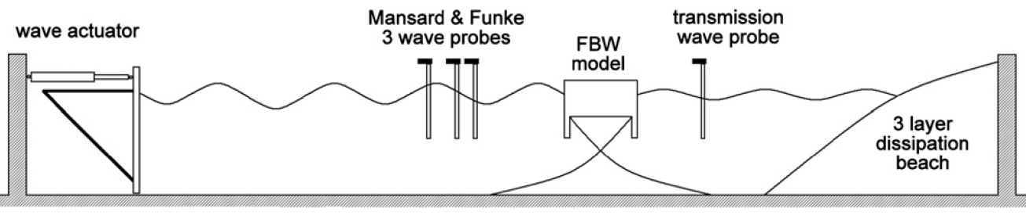

Figure 1. Schematic layout of the CITEEC wave basin.
These tests were carried out on four π-type FB models with various geometric characteristics. The model A, which is one of the four experimental models, has width and draft of 0.267m and 0.12m respectively. This model reproduced a real prototype sample, already installed at the Baiona Port (Peña et al., 2011). The model A is a basis for comparing the performance of different π-type FB models. Models B and D are other experimental models; these models were built with the aim of taking into account the effect of the width of the π-type FB on its performance. Model B with a width reduction of 10% in comparison with the model A was tested. Model D consists of two rows of modules, identical to the Model A, placed parallel to each other so they work together as only a bigger one. In order to evaluate the effect of the draft on the π-type FB performance, model C was built. In this model the height of the lateral fins was increased by 50%. Table 1 shows a resume of the different mentioned experimental models.

Table 1. Specifications of the different experimental models tested.
Experimental Models | width | draft | Description
Model A | 0.267 | 0.12 | Baiona Port FB | 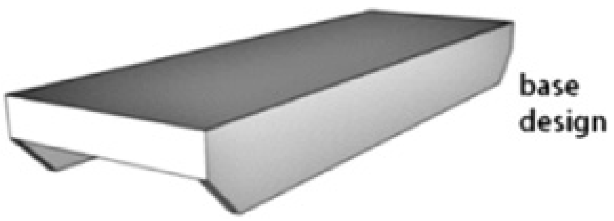
Model B | 0.24 | 0.12 | Width reduction (10%) regarding model A | 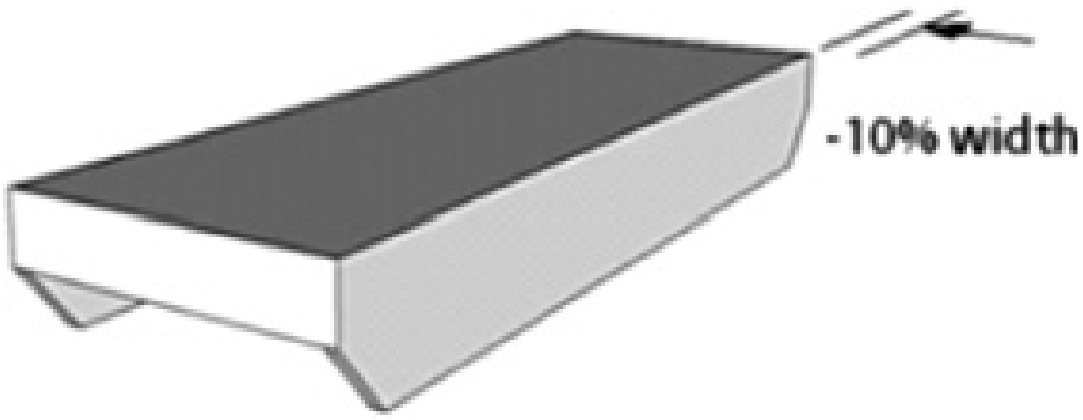
Model C | 0.267 | 0.1433 | Lateral fin prolongation (50%) regarding model A | 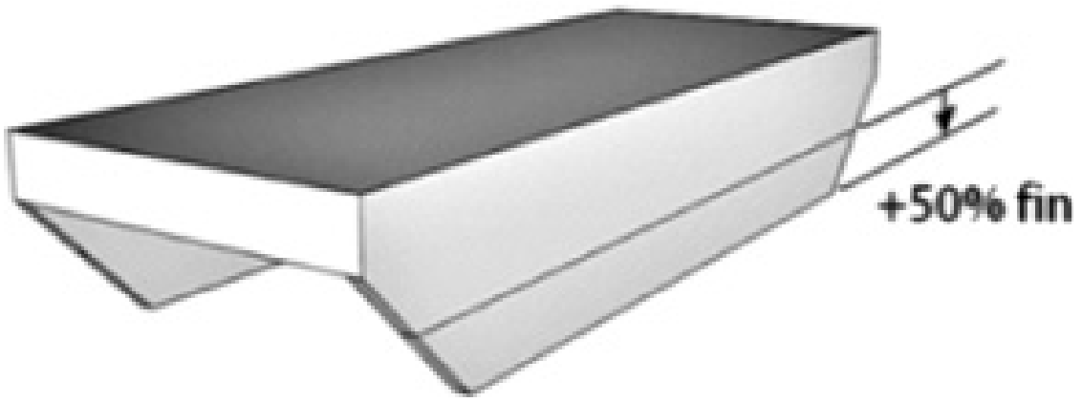
Model D | 0.533 | 0.12 | Two parallel module  rows, in this study without separation | 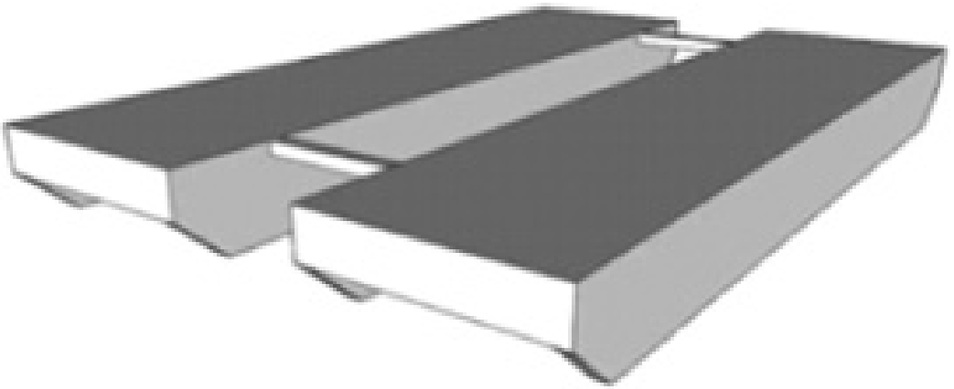

The wave characteristics and structure dimension parameters considered in the experiments are shown in Table 2. It should be noted that the number of tests conducted on the four aforementioned models is 134 and the tests were carried out with the scale of 1:15.

Table 2. Experimental setup parameters for the π-type FB models.
Parameters | Experimental range
Depth of water, d (m) | 0.35, 0.45, 0.55
Wave period, T_{p} (s) | 0.6, 0.7, 0.75, 0.8, 0.85, 0.9, 0.95, 1, 1.1, 1.5, 2
Incident wave height, H (m) | 0.02, 0.04, 0.06, 0.08, 0.1
breakwater width, W (m) | 0.24, 0.267, 0.533
breakwater draft, dr (m) | 0.12, 0.1433

Selection of input variables
One of the most important steps in developing a satisfactory forecasting model is the selection of the input variables. The K_{t} of π-type FBs is a function of the geometry of structural and wave hydrodynamic characteristics. Geometry of structural include: FB width (W), FB draft (dr), natural oscillation of the FB (T_{h}), degrees of freedom, brace type of FB and FB weight. Hydrodynamic characteristics include: water depth (d), incident wave height (H) and incident peak wave period (T_{p}).
According to previous studies, the dependency of the K_{t} to various dimensionless parameters can be reviewed. Dong et al. (2008) studied the effect of H/L parameter and revealed the K_{t} is decreased with the increase of this parameter. Two other parameters W/L and dr/d were considered by Koutandos et al. (2005) and Peña et al. (2011) and showed that the increase of these parameters led to the reduction of the K_{t}. Ruol et al. (2012) introduced the T_{p}/T_{h} parameter and represented the direct linear dependency of this parameter with the K_{t}.
In the current study, based on the previous researches judgments, the dimensionless parameters H/L, W/L, T_{p}/T_{h}, and dr/d were adopted as the input variables to the models while its output was selected to be the K_{t}. The number of experimental tests utilized in this study are 134, from which 107 has been used for training the models and the remaining 27 tests have been used for evaluating the performance of the established models in predicting the K_{t}. The range of values used for training and testing the models is reported in Table 3.

Table 3. The ranges of the input parameters.
 | Training data |  |  |  | Testing data
parameters | Min | Max | Mean | Standard  deviation | Min | Max | Mean | Standard  deviation
H/L | 0.008 | 0.107 | 0.0531 | 0.0259 | 0.006 | 0.107 | 0.0557 | 0.0253
W/L | 0.069 | 0.949 | 0.2793 | 0.1584 | 0.069 | 0.537 | 0.2754 | 0.1158
T_{p}/T_{h} | 0.594 | 2.431 | 1.0715 | 0.3545 | 0.677 | 2.431 | 1.0465 | 0.3565
dr/d | 0.218 | 0.343 | 0.2911 | 0.0441 | 0.218 | 0.343 | 0.2897 | 0.0448

It should be noted, the T_{h} value of different experimental models is calculated by using Eq. 2 (Ruol et al. 2012).
$T_{h}=2π\sqrt{\frac{\text{dr}+0\text{.}\text{35}W}{g}}$ (2)
where g is the acceleration of gravity and its value is 9.81 m/s² on Earth.

A new hybrid ANN model
Artificial neural networks are flexible computational devices, which are used for modeling a wide range of nonlinear problems. These networks have the ability to modeling the particular problem without prior knowledge about it. Actually, this modeling is based on knowledge of the input training pattern to the network. There are many different types of ANNs, while the ANN used in this study is a three-layer feedforward network. This network consists of three layers and each layer is comprised of a number of simple processing elements called neurons. The neurons of the input layer are the dimensionless parameters H/L, W/L, T_{p}/T_{h}, and dr/d, as was mentioned in the previous section. The K_{t} prediction is the only neurons of the output layer. The neurons of hidden layers are used to process the information received by the input layer neurons. The connection weights are the connectivity element between neurons in adjacent layers. Network learning is carried out by changing the connection weights when processing each of the training patterns. There are numerous algorithms available for learning ANNs, which in this study the Levenberg–Marquardt (LM) algorithm is used.
Particle swarm optimization (PSO) is a population-based stochastic optimization approach that solves a problem by iteratively trying to find an optimal response. The PSO was developed by Eberhart and Kennedy in 1995, inspired by the collective behavior of some animals such as bird flocking or fish schooling (Kennedy and Eberhart. 1995). The PSO algorithm begins by a set of particles that each particle has a position vector, a velocity vector, and a fitness value. The components of particle's position vector are the response of a problem that the PSO tries to find the optimal value for it.
Random selection of ANN initial connection weights is a weakness in the process of ANN learning. If the random section is far from the optimal response, then learning process of ANN will need to use the large numbers of iteration. Therefore, the convergence speed of ANN learning will be reduced. Also if the initial connection weights located near local minimum, the algorithm would be stuck at a sub-optimal response. Generally, the finding of optimal weights is strongly dependent on initial weights, so in this paper to improve the learning process of ANN, the adjustment of network initial weights using the PSO algorithm was proposed as a strategy.
The process of achieving the optimal response by proposed algorithm is as follows:
Phase 1: data preprocessing
- Step 1: examine the experimental data
- Step 2: selection of input and output variables
- Step 3: the experimental data divided into the training and testing data
Phase 2: Learning ANN by using PSO algorithm
- Step 1: selection of network architecture
One of the most important steps in designing an ANN is the selection of network architecture. The ANN used in this study is a three-layer feedforward network. In this network, architecture is dependent on choosing the number of hidden layers and the number of neurons in each layer of the network and the type of transfer function in the hidden and output layers. The number of neurons in the input layer is the same as the number of the input variables which is 4 in this study. The output layer is composed of a neuron which represents K_{t}. The hyperbolic tangent sigmoid and linear transfer functions in the hidden and the output layer respectively, were used in all networks. In order to find the best architecture, ANNs with one and two hidden layers have been designed in which the number of neurons in the hidden layers is from 4 to 6 neurons.
- Step 2: randomly initialize population positions and velocities
As previously was mentioned, each particle has a position and velocity vector. In this problem, the components of particle's position vector are connection weights of ANN. In the first iteration of the learning process by PSO, position and velocity vectors of particles are randomly selected. For example, the network with the architecture of 4-5-5-1 has 61 connection weights. It should be noted, in this study, the number of 200 particles is selected for learning different network by the PSO algorithm.
- Step 3: update particle velocity
velocity vector of particles is updated by the Eq. 3.
$v_{i}^{t}=ω v_{i}^{t−1}−r_{1}c_{1}(x_{\text{Pbesti}}−x_{i}^{t−1})+r_{2}c_{2}(x_{\text{gbest}}−x_{i}^{t−1})$ (3)
where r₁ and r₂ are the random numbers between 0 and 1; c₁ and c₂ are the acceleration constants, the value of c₁ and c₂ is taken to be 2 for this study; ω is called inertia weight; x_{i}^{t-1} is the particle's current position; and v_{i}^{t-1} particle's current velocity. x_{pbest} is the particle's local best position, and x_{gbest} is global best position of the particles population.
- Step 4: update particle position
Particle's position vector is updated by the Eq. 4.
$x_{i}^{t}= x_{i}^{t−1} + v_{i}^{t}$ (4)
- Step 5: calculate fitness value
Each particle has a position vector that the component of this vector is connection weights of ANN. Therefore, using the training data, the output value of ANN for each particle can be calculated.
The output of three-layer feedforward network is calculated by the Eq. 5:
$Y_{n}=w_{0}+\sum_{j=1}^{L}{w_{j}\text{.}f(w_{0j}+\sum_{i=1}^{4}{w_{\text{ij}}x_{i})}}$ (5)
where w is connection weights; x is input variable; L is the number of hidden layer neurons; Y is network output and f is transfer function. Transfer function can take several forms. In this study, the linear function is used as transfer function of the output layer and hyperbolic tangent sigmoid function is selected as transfer function of the hidden layers.
After the value of network output for each particle was calculated by using Eq. 5, the cost function can be calculated by using Eq. 6. The cost function is same as the fitness value of particle.
In this study, the root mean square error (RMSE) as the cost function given below is used:
$\text{RMSE}=\sqrt{\frac{1}{N}\sum_{n=1}^{N}{{\left(A_{n}−Y_{n}\right)}^{2}}}$ (6)

where Y and A are network output and actual value respectively and N is the number of data set.
- Step 6: Determine the values of x_{gbest} and x_{pbest}
After the values of position, velocity and fitness for each particle are determined, the x_{pbest} value of each particle and x_{gbest} of particles population should be determined.
- Step 7: evaluation of stopping criterion
The algorithm is terminated after a given number of iterations. In this study, the number of 100 iterations is considered as a stopping criterion. Whenever the stopping criterion was achieved, the learning process will be completed and the x_{gbest} value will be considered as the optimal response, otherwise the learning process will be repeated from Step 4 to 7.
Phase 3: Learning ANN by using LM algorithm
- Step 1: initializing network weights by PSO
The optimal response obtained in the previous phase by PSO algorithms is considered as initial weights.
- Step 2: calculate fitness value
The mean square error (MSE) as the cost function given below is used:
$E=\frac{1}{N}\sum_{n=1}^{N}{(Y_{n}−A_{n})^{2}}$ (7)
where E is the error or cost function (mean squared error), actually it is an overall accuracy criterion; Y is predicted value and its value is obtained by Eq. 5; and A is actual value; N is the number of data set.
- Step 3: updated ANN weights by LM algorithm
In order to train a neural network, we must adjust the connection weights of network in such a way that the error obtained from the Eq. 7 is minimized. This process requires that the ANN compute the error derivative of the connection weights, according to the following equation:
$Δw=−η\frac{∂E}{∂w}$ (8)
where, the parameter η is the learning rate, and ∂E/∂W is the partial derivative of the function E with respect to the matrix w.
The Levenberg–Marquardt (LM) algorithm is the most widely used method for determining the error derivative of the connection weights. A detailed account of learning ANN by LM algorithm can also be found in Hagan and Menhaj (1994).
- Step 4: evaluation of stopping criterion
If the stopping criterion was achieved, connection weights obtained from step 3 will be considered as final response of the hybrid algorithm, otherwise the LM algorithm will be repeated from Step 2 to 4.
Phase 4: data past processing
- Step 1: test the ANN using testing data
The performance of the hybrid ANNs in K_{t} predicted is evaluated using some well-known statistical measures. These parameters are: Correlation Coefficient (CC) and Root Mean Square Error (RMSE), which are defined as:
$\text{CC}=\frac{\sum_{i=1}^{N}{(X_{i}−\overline{X})}(Y_{i}−\overline{Y})}{\sqrt{\sum_{i=1}^{N}{(X_{i}−\overline{X})^{2}}(Y_{i}−\overline{Y}})^{2}}$ (9)
$\text{RMSE}=\sqrt{\frac{1}{N}\sum_{i=1}^{N}{(X_{i}−Y_{i})^{2}}}$ (10)
where Y and X are predicted and measured K_{t} respectively and N is the number of data set. Also X̅ and Y̅ represent the average predicted and measured K_{t} respectively.
- Step 2: extending the experimental results by using hybrid ANN model
- Step 3: obtain the optimal design of π-type FB

Figure 2. Flowchart of Learning ANN by using PSO-LM algorithm

Results
In order to find the best architecture, the ANN models with different architectures were designed. The difference among various network architectures is the number of hidden layers (one and two layers) and the number of neurons of these layers (4 to 6 neurons). The architectures used in this study can be seen in the first column of table 3. For example, ANN with the architecture of 4-5-6-1 is made of two hidden layers with 5 and 6 neurons. After the selection of network architecture, using the training data, the ANN models were learned by the PSO-LM algorithm. The number of LM algorithm learning iterations has been shown in the second column of table 3.

Table 3. Statistical measures for different ANN models.
Architecture | Epoch | CC | RMSE
4-5-6-1 | 50 | 0.969 | 0.0593
4-6-6-1 | 90 | 0.968 | 0.0604
4-5-4-1 | 90 | 0.967 | 0.0620
4-4-6-1 | 35 | 0.964 | 0.0649
4-6-1 | 80 | 0.962 | 0.0666
4-5-5-1 | 25 | 0.962 | 0.0671
4-6-5-1 | 70 | 0.959 | 0.0686
4-4-5-1 | 70 | 0.960 | 0.0688
4-6-4-1 | 20 | 0.954 | 0.0726
4-4-4-1 | 30 | 0.954 | 0.0728
4-4-1 | 40 | 0.951 | 0.0750
4-5-1 | 100 | 0.950 | 0.0754
According to this column, it can be concluded that the convergence speed of ANN is increased due to using the PSO-LM algorithm. Then, using the testing data, the performance of different networks for the prediction of the K_{t} of π-type FBs is investigated by CC and RMSE indicators (the third and fourth columns of table 3). According to the table 3, it can be concluded that the ANN with the architecture of 4-6-5-1 has the best performance.
The best network with the architecture of 4-5-6-1 is made of the number of 68 connection weights. So it can be concluded that particle's position vector has 68 components. Since the best network is initially learned by the PSO algorithm, it should be expected that the LM algorithm obtains the optimal response with a low number of iterations. The authenticity of the claim can be seen in Fig. 3.

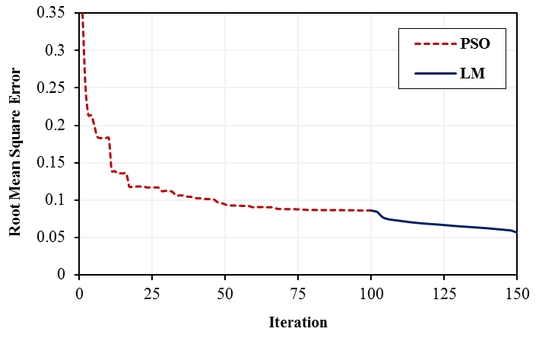
Figure 3. The RMSE values, during learning the best hybrid ANN by using PSO-LM algorithm.

Generally, Fig. 3 shows the convergence process of the best hybrid ANN during different iterations of the PSO-LM algorithm. From this figure, it can be concluded that pre-learning best network by PSO-LM algorithm leads to be closer to the global optimal response.
After finding the best network, its performance for the prediction of wave transmission of π-type FB was evaluated by training and testing data. Table 4 shows the statistical measures like CC, and RMSE for the best hybrid ANN.

Table 4. Statistical measures for the best hybrid ANN.
The best ANN | Training data |  | Testing data
The best ANN | CC | RMSE | CC | RMSE
4-5-6-1 | 0.9712 | 0.0563 | 0.9691 | 0.0593

From Table 4 it was found that the best hybrid ANN is able to the prediction of the K_{t} parameter because CC is higher than 0.969 for total data and the RMSE is lower than 0.06 for total data. Fig. 4 shows a comparison made between the predicted wave transmission by the best hybrid ANN and the measured values. Based on this figure, the more the data points are closer to the x=y line and the less they are scattered. So it can be concluded that the best hybrid ANN is able to provide a good prediction of the K_{t} parameter.
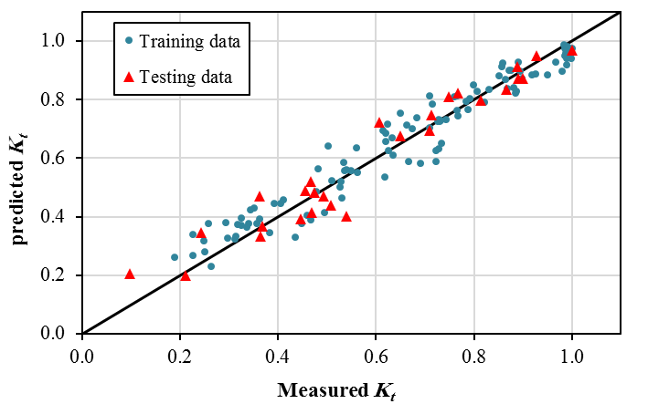
Figure 4. Comparison of predicted and measured K_{t} for the best hybrid ANN.

So far the only formula for the predicting the K_{t} of the π-type FBs has been presented by Ruol et al. (2012). This formula is given as
$K_{t}=\frac{1}{1+\left(\frac{χ−χ_{0}}{σ}\right)e^{−{\left(\frac{χ−χ_{0}}{σ}\right)}^{2}}}×\frac{1}{\sqrt{1+{\left(\text{Kw}\frac{\text{sinh}\text{Kd}}{2\text{cosh}\left(\text{Kd}−\text{Kdr}\right)}\right)}^{2}}}$ (10)
where k (=2 π/ L) is the wave number, χ (=T_{p}/T_{h}) is the dimensionless parameter, χ₀ and σ are 0.7919 and 0.1922 respectively.
Fig. 5 and Table 5 show a comparison made between the predicted K_{t} by the best hybrid ANN and the Ruol’s formula together with the measured ones for data reported in Peña et al (2011). From Fig. 5 and Table 5, it can be concluded that the best hybrid ANN has had a better performance compared with Ruol’s formula for predicting the K_{t} of π-type FBs.

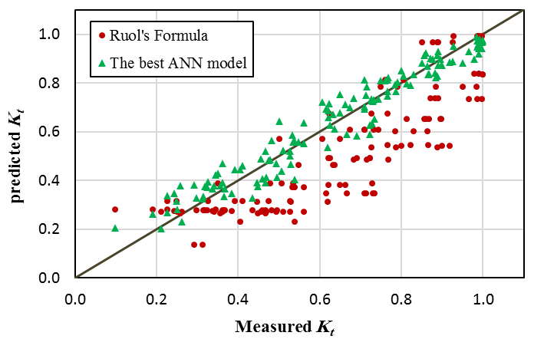

Figure 5. Comparison of predicted and measured K_{t} for the best hybrid ANN model and Ruol's formula.

Table 5. Statistical measures for the best hybrid ANN and Ruol's formula.
 | Total data
Model | CC | RMSE
The best hybrid ANN | 0.9708 | 0.0569
Ruol's formula | 0.8550 | 0.1834

Peña et al. (2011) used the T50 parameter as a criterion according to which the performance of FBs can be evaluated and compared against each other. T50 is the period of the incident wave for which a K_{t}=0.5 value is recorded for the FB. For periods smaller than T50, the K_{t} becomes smaller than 0.5 implying the structure’s performance to be acceptable for these periods. Since the exact value of T50 parameter was not known to Peña et al. (2011), they introduced the possible range of the T50 for each experimental model and used these ranges for comparisons between the performance of different FBs. In this study, the best hybrid ANN has been used for extending experimental data due to its good performance in predicting the K_{t}.
Using the best hybrid ANN, the K_{t} value of different experimental models has been predicted for various properties of the incident wave and the precise T50 values for different experimental models are presented in Table 6. The improvement percentage of each model in compare with model A is also presented in this table. As an example, for an incident wave with H=0.06m, a 10% reduction in structure width (model B) yields in a 3% reduction to the performance and a 100% increase in structure width (model D) leads to a 35% improvement to the performance while a 100% increase of fins height (model C) has led to a 15% improvement to the performance.

Table 6. Critical period and percent improvement in performance of the FB experimental models obtained from the best hybrid ANN.
 |  | H=0.04m |  | H=0.06m |  | H=0.07m
Model | K_{t} | T_{p} (s) | % | T_{p} (s) | % | T_{p} (s) | %
A | 0.5 | 0.775 | 0 | 0.715 | 0 | 0.690 | 0
B | 0.5 | 0.715 | -8 | 0.690 | -3 | 0.665 | -4
C | 0.5 | 0.865 | 12 | 0.820 | 15 | 0.775 | 12
D | 0.5 | 0.950 | 23 | 0.965 | 35 | 0.975 | 41

To study the effect of structure width on the K_{t} of FBs, the K_{t} value of structures with different widths has been computed using the best hybrid ANN. The resulted values are illustrated in Fig. 6 in which H=0.06m, dr=0.12m, and d=0.45m are assumed to remain constant. The structure with W=0.267m is called model A which shares all its properties except the width parameter with other considered structures. In alternative structures, the width parameter has been subjected to either 10% or 30% change which has been applied in either reduction or increase form. As can be seen in Fig. 6, a width increase has led to the K_{t} reduction in all periods.

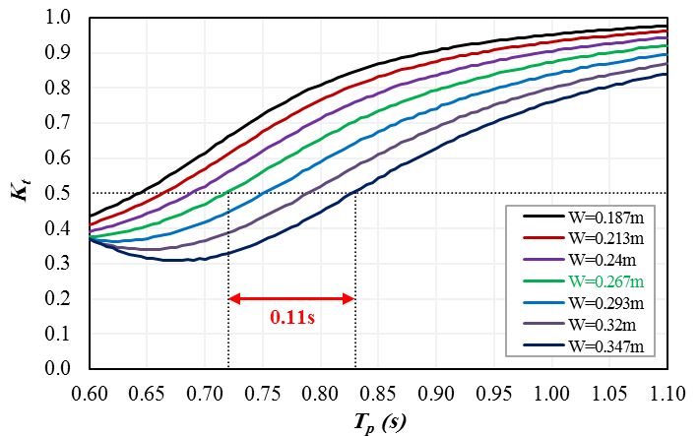

Figure 6. Variations of K_{t} with wave period for FBs with various width.

The T50 values of various structures have also been obtained using Fig.6 and tabulated in Table 7 for comparison purposes. The T50 values are accompanied by the performance improvement percentage provided by different models relative to the model A. As the table values suggest, a 30% increase of width has led to an 15% improvement of the performance.

Table 7. The effect of changing the width of FB to improve its performance.
Width (m) | K_{t} | T_{p} (s) | Improve (%)
0.187 | 0.5 | 0.645 | -10
0.213 | 0.5 | 0.665 | -8
0.24 | 0.5 | 0.69 | -4
0.267 (Model A) | 0.5 | 0.72 | 0
0.293 | 0.5 | 0.75 | 4
0.32 | 0.5 | 0.79 | 10
0.347 | 0.5 | 0.83 | 15

Other of the important and effective parameters on the performance of FBs is the draft. The K_{t} value of structures with different drafts has been computed, using the best hybrid ANN. The resulted values are illustrated in Fig. 7 in which H=0.06m, W=0.267m, and d=0.45m are assumed to remain constant. The structure with dr=0.12m is model A which shares all its properties except the draft parameter with other mentioned structures. As can be seen in Fig. 7, a draft increase has led to the K_{t} reduction in all periods.

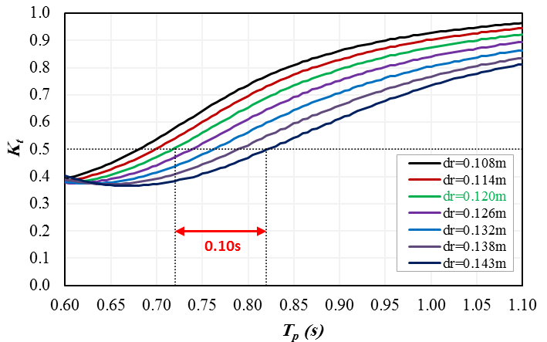

Figure 7. Variations of K_{t} with wave period for FBs with various draft.

The T50 values of various structures have also been obtained using Fig. 7 and tabulated in Table 8 for comparison purposes. The T50 values are accompanied by the performance improvement percentage provided by different models relative to the model A. As the table values suggest, a 100% increase of fins height has led to a 14% improvement of the performance.

Table 8. The effect of changing the draft of FB to improve its performance.
draft (m) | K_{t} | T_{p} (s) | Improve (%)
0.108 | 0.5 | 0.68 | -5
0.114 | 0.5 | 0.7 | -3
0.12 (Model A) | 0.5 | 0.72 | 0
0.126 | 0.5 | 0.74 | 3
0.132 | 0.5 | 0.76 | 6
0.138 | 0.5 | 0.79 | 10
0.143 | 0.5 | 0.82 | 14

As can be seen from the Figs. 6 and 7, a 30% increase of width and a 20% increase of draft has led to 15% and 14% improvement of the performance respectively. Of course, these changes in the draft are proportional to the changes in the height of the fins. Generally, it can be concluded that the effect of the increased width or draft has the same order to influence on the results obtained for the K_{t}.
Fig. 8 shows the evolution of the K_{t} against the wave heights (H) for different values of T_{p} obtained from the best hybrid ANN. In this figure, W=0.267m, dr=0.12m, and d=0.45m values are assumed to remain constant.
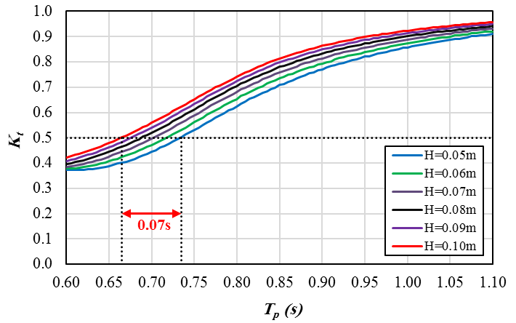

Figure 8. Variations of the K_{t} with wave period for FB with various wave height.

Fig. 8 shows a 100% decrease of wave height has led to 0.07s decrease of T50, so it can be concluded the variation of wave height has no major effect on the FB performance.

Conclusions
Regarding the π-type floating breakwaters, the vertical plates provide an efficient and economic improvement to the performance of rectangular FB through increase of draft. In the present study, the hybrid ANN models is developed by the use of experimental data sets to predict the K_{t} of the π-type FBs. Its performance in the predicted by the indicators errors was evaluated; the results show that the hybrid ANN can be successfully used for the prediction of the K_{t} and this model has a good performance compared to that of the Ruol’s formula.
In the learning ANN, using the PSO algorithm for proposing the initial weights of ANN shows that the ensuring to achieve optimal response and the convergence speed of LM algorithm are enhanced.
Since the hybrid ANN model has high accuracy, this model can be used for extending the experimental data. Doing so, the effect of structure’s geometric properties and hydrodynamic characteristics of waves can be evaluated on the performance of the π-type FBs. Results obtained through this study show that variation of wave height has no major effect on the FB performance. Also, comparison of fins height and width increasing the performance of FB show that the earlier one is more economical for the same FB performance.

REFERENCES
Castro, A., and F.T. Pinto. 2012. Artificial intelligence applied to plane wave reflection at submerged breakwaters, Journal of Hydraulic Research, 49, 465-472.
Cha, D., H. Zhang, and M. Blumenstein. 2011. Prediction of maximum wave-induced liquefaction in porous seabed using multi-artificial neural network model, Ocean Engineering, 38(7), 878-887.
Cho, Il-H. 2016. Transmission coefficients of a floating rectangular breakwater with porous side plates, International Journal of Naval Architecture and Ocean Engineering, 8(1), 53-65.
Dong, G.H., Y.N. Zheng, Y.V. Li, B. Teng, C.T. Guan, and D.F. Lin. 2008. Experiments on wave transmission coefficients of floating breakwaters, Ocean Engineering, 35(8–9), 931-938.
Ferreras, J., E. Peña, A. Lopez, and F. Lopez. 2014. Structural performance of a floating breakwater for different mooring line typologies, Journal of Waterway, Port, Coastal and Ocean Engineering, 140(3), 1-10.
Filippo, A., A.R. Torres, B. Kjerfve, and A. Monat. 2012. Application of Artificial Neural Network (ANN) to improve forecasting of sea level, Ocean & Coastal Management, 55, 101-110.
Gesraha, M.R. 2006. Analysis of π shaped floating breakwater in oblique waves: I. Impervious rigid wave boards, Applied Ocean Engineering, 28(5), 327-338.
Hagan, M.T, and M.B. Menhaj. 1994. Training feedforward networks with the Marquardt algorithm, IEEE Transactions on Neural Networks, 5(6), 989-993.
Harish, N., S. Mandal, S. Rao, and S.G. Patil. 2015. Particle Swarm Optimization based support vector machine for damage level prediction of non-reshaped berm breakwater, Applied Soft Computing, 27, 313-321.
Hashim, R., Ch. Roy, Sh. Motamed, Sh. Shamshirband, and D. Petković. 2016. Selection of climatic parameters affecting wave height prediction using an enhanced Takagi-Sugeno-based fuzzy methodology, Renewable and Sustainable Energy Reviews, 60, 246-257.
He, F., Z. Huang, and A.W.K. Law. 2012. Hydrodynamic performance of a rectangular floating breakwater with and without pneumatic chambers: An experimental study, Ocean Engineering, 51(1), 16-27.
Hegde, A.V., K. Kamath, and A.S. Magadum. 2007. Performance characteristics of horizontal interlaced multilayer moored floating pipe breakwater, Journal of Waterway, Port, Coastal and Ocean Engineering, 133(4), 275-285.
Huang, Z., F. He, and W. Zhange. 2014. A floating box-type breakwater with slotted barriers, Journal of Hydraulic Research, 52(5), 720-727.
Ji, C.h., X. Chen, J. Cui, O. Gaidai, and A. Incecik. 2016. Experimental study on configuration optimization of floating breakwater, Ocean Engineering, 117, 302-310.
Ji, C.h., X. Chen, J. Cui, Z. Yuan, and A. Incecik. 2015. Experimental study of a new type of floating breakwater, Ocean Engineering, 105, 295-303.
Karimi, S., O. Kisi, J. Shiri, and O. Makarynskyy. 2013. Neuro-fuzzy and neural network techniques for forecasting sea level in Darwin Harbor Australia, Computers & Geosciences, 52, 50-59.
Kennedy, J., and R. Eberhart. 1995. Particle swarm optimization, Proceedings of IEEE International Conference on Neural Networks, 4, 1942–1948.
Koftis, T.H, P. Prinos, and E. Koutandos. 2006. 2D-V hydrodynamics of wave–floating breakwater interaction, Journal of Hydraulic Research, 44(4), 451-469.
Koraim, A.S. 2013. Hydrodynamic efficiency of suspended horizontal rows of half pipes used as a new type breakwater, Ocean Engineering, 64, 1-22.
Koutandos, E., P. Prinos, and X. Gironella. 2005. Floating breakwaters under regular and irregular wave forcing: reflection and transmission characteristics, Journal of Hydraulic Research, 43(2), 174-188.
Mandal, S., S. Rao, N. Harish, and N. Lokesha. 2012. Damage level prediction of non-reshaped berm breakwater using ANN, SVM and ANFIS models, International Journal of Naval Architecture and Ocean Engineering, 4, 112-122.
Ozeren, Y., D.G. Wren, M. Altinakar, and P.A. Work. 2011. Experimental investigation of cylindrical floating breakwater performance with various mooring configurations, Journal of Waterway, Port, Coastal and Ocean Engineering, 137(6), 300–309.
Özger, M. 2009. Neuro-fuzzy approach for the spatial estimation of ocean wave characteristics, Advances in Engineering Software, 40(9), 759-765.
Özger, M. 2010. Significant wave height forecasting using wavelet fuzzy logic approach, Ocean Engineering, 37(16), 1443-1451.
Özger, M. 2011. Prediction of ocean wave energy from meteorological variables by fuzzy logic modeling, Expert Systems with Applications, 38(5), 6269-6274.
Patil, S.G., S. Manda, A.V. Hegde, and A. Srinivasan. 2011. Neuro-fuzzy bases approach for wave transmission prediction of horizontally interlaced multilayer moored floating pipe breakwater, Ocean Engineering, 38(1), 186-196.
Patil, S.G., S. Mandal, and A.V. Hegde. 2012. Genetic algorithm based support vector machine regression in predicting wave transmission of horizontally interlaced multilayer moored floating pipe breakwater, Advances in Engineering Software, 45(1), 203-212.
Peña, E., J. Ferreras, and F. Sanchez-Tembleque F. 2011. Experimental study on wave transmission coefficient, mooring lines and module connector forces with different designs of floating breakwaters, Ocean Engineering, 38(10), 1150-1160.
Ruol, P., L. Martinelli, and P. Pezzuto. 2012. A formula to predict Transmission for π-type floating breakwaters, Journal of Waterway, Port, Coastal and Ocean Engineering,139(1), 1–8.
Yin, J., N. Wang, and J. Hu. 2015. A hybrid real-time tidal prediction mechanism based on harmonic method and variable structure neural network, Engineering Applications of Artificial Intelligence, 41, 223-231.
Zanaganeh, M, J. Mousavi, and A.F Etemad-Shahidi. 2009. A hybrid genetic algorithm–adaptive network-based fuzzy inference system in prediction of wave parameters, Engineering Applications of Artificial Intelligence, 22(8), 1194–1202.

Department of Civil and Environmental Engineering, Amirkabir University of Technology, Tehran, , Iran
Department of Civil and Environmental Engineering, Amirkabir University of Technology, Tehran, Iran
Civil Engineering School, University of A Coruña, Campus de Elviña, s/n. A Coruña, 15071, Spain
Civil Engineering School, University of A Coruña, Campus de Elviña, s/n. A Coruña, 15071, Spain
Civil Engineering School, University of A Coruña, Campus de Elviña, s/n. A Coruña, 15071, Spain

